

Exhibition Access Guide
Olivia Bax
Double Take

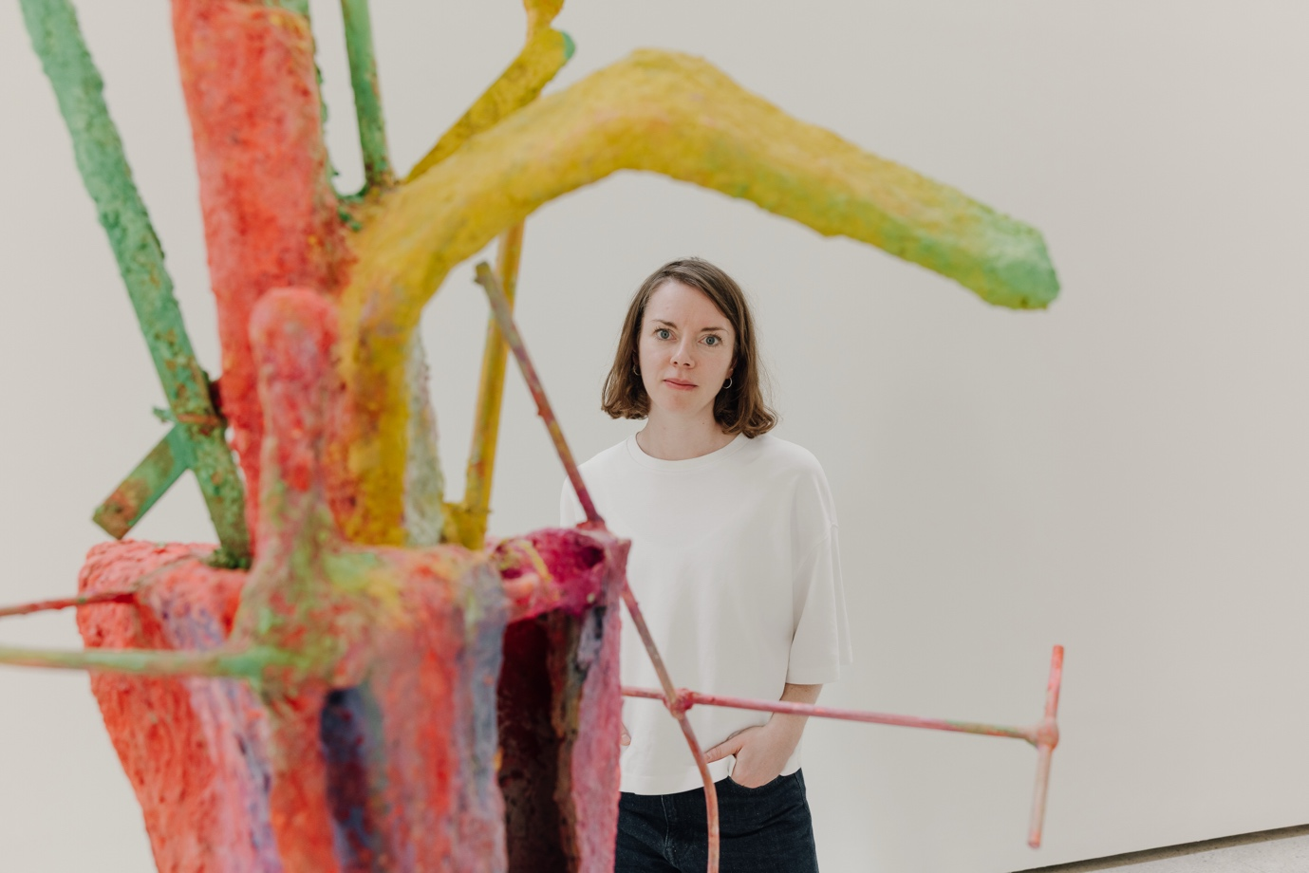

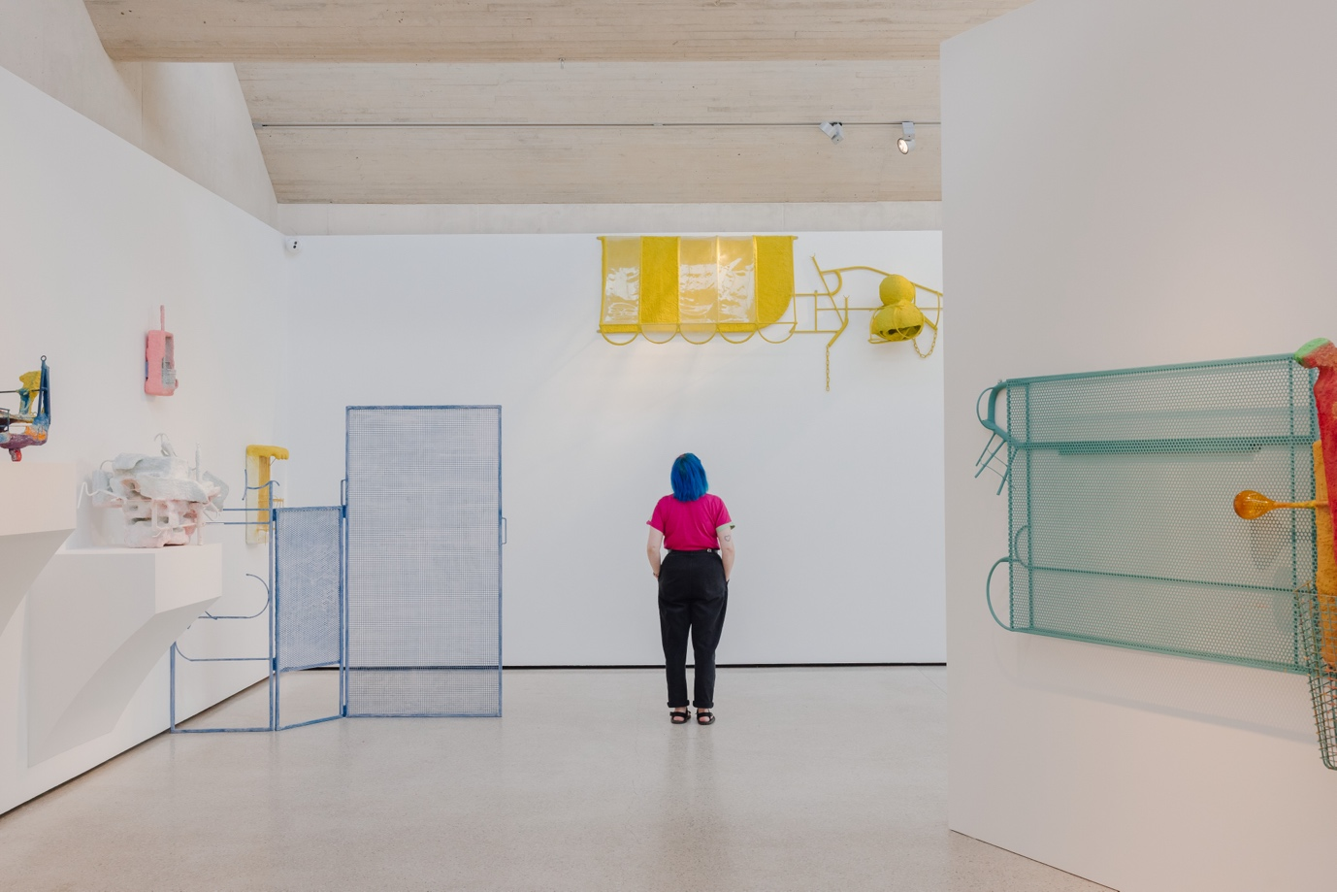

About the exhibition

Double Take is the latest exhibition in The Weston Gallery at Yorkshire Sculpture Park. It is an exhibition of colourful sculptures, made with recycled materials by artist, Olivia Bax.

Olivia Bax combines metal mesh with everyday items like shopping trolleys and beach balls to create her sculptures. Each sculpture is covered in plaster made from recycled paper pulp. This gives her artwork an organic texture. This paper pulp is painted in bright colours, with paints saved from landfill. Recycling is a key theme in Olivia’s artwork. By reworking these objects and materials into sculptures, she gives them a new life. Her artwork is bright and playful. By using household objects, her sculptures show a familiar view of daily life.

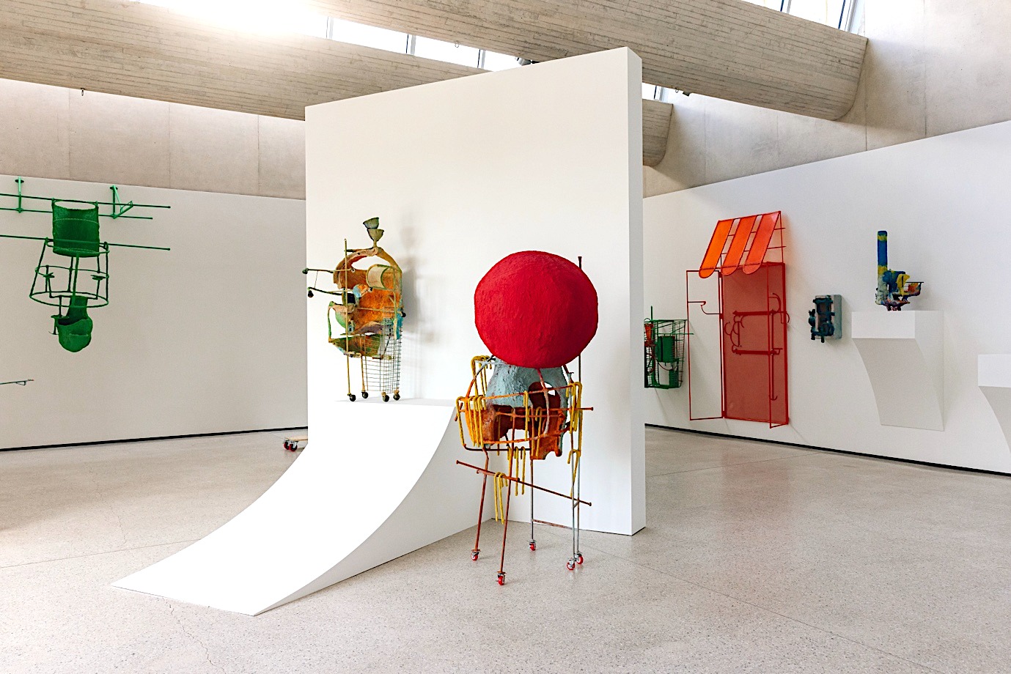

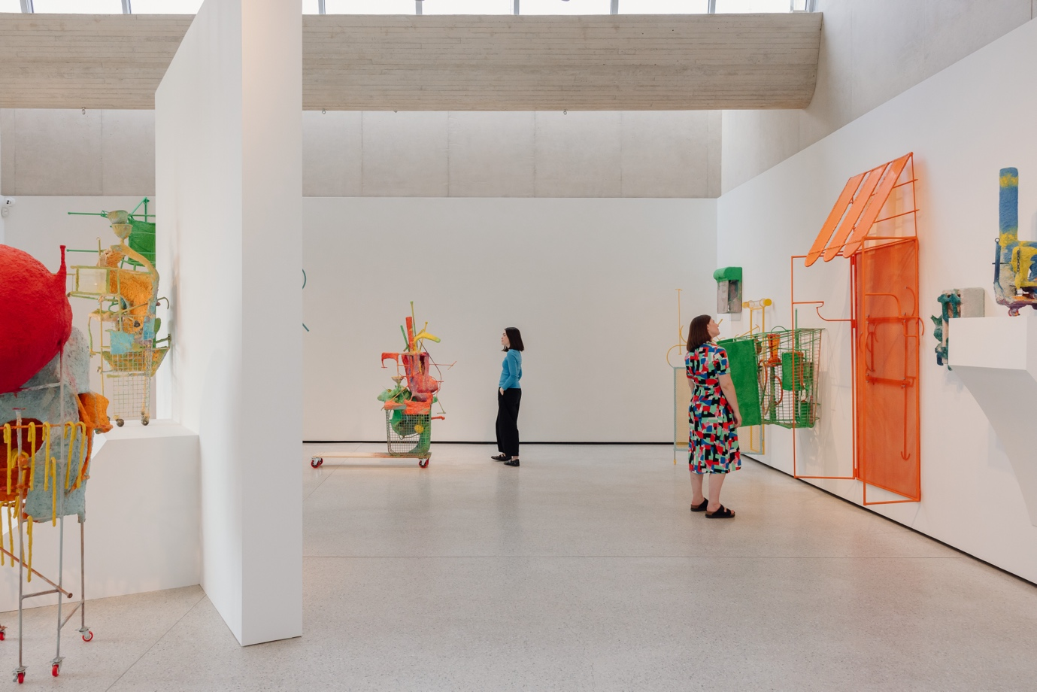
Most of the sculptures hang from the gallery walls at different heights, so that the artworks can be explored from all angles. Some larger sculptures stand freely on the floor, to allow a closer look. A dividing wall separates the space, encouraging visitors to explore the exhibition in a circular loop of the gallery.

Visitors are welcome to move around the sculptures to explore them from different angles, without touching. Wheelchair access is available throughout the gallery.

Exhibition Information

As you enter the gallery, there is information about the exhibition on your left. On your right, this information is available in different formats including;

- Large print
- Braille
- Audio - you can listen to this via a QR code on your own device or ask a member of YSP staff to listen on the iPad in the gallery.


Scan this QR code to listen to the introduction to Olivia Bax: Double Take

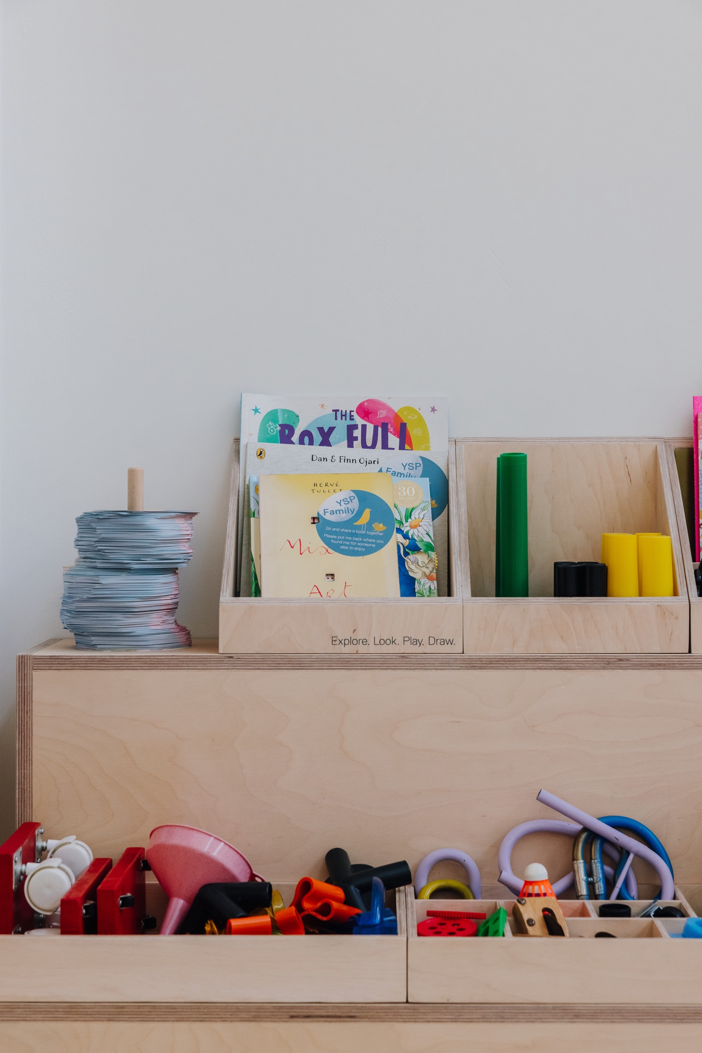

Exhibition Resources

For each exhibition at YSP, our teams create and collect a range of resources to encourage visitors to explore the themes of the exhibition more deeply. For this exhibition, the resources are focused on sculpture building and playful looking.

Here’s a list of all of the resources you can find in The Weston for this exhibition.

- A selection of found objects, similar to those found in Olivia’s sculpture. Pick up a shopping basket and collect from the pick’n’mix to make your own colourful sculptures in the gallery.

- Books for families.

- Drawing Together – pick up a clipboard with colourful paper, pencils and creative prompts attached, to explore the exhibition through drawing.

- Looking Kits – pick up a lanyard with a range of different viewfinders and creative prompts attached, to explore the exhibition through playful looking.

- Free Paper View Finders – pick up a paper view finder and take it with you on your journey through YSP. These view finders contain creative prompts to encourage playful looking while you explore the park.

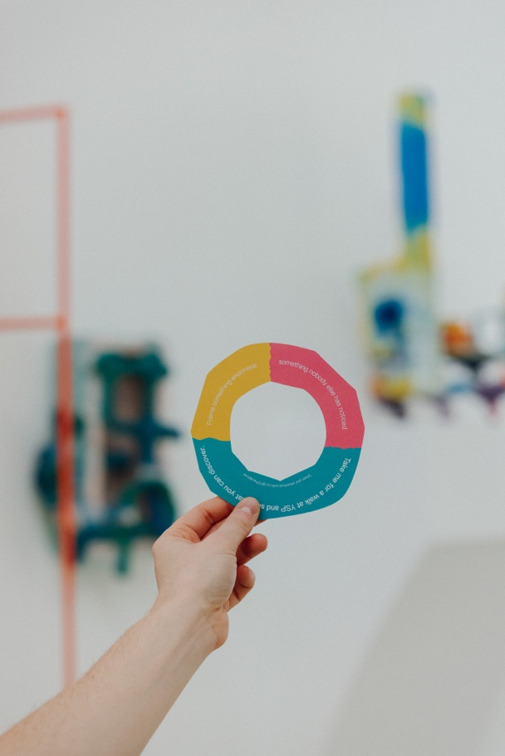
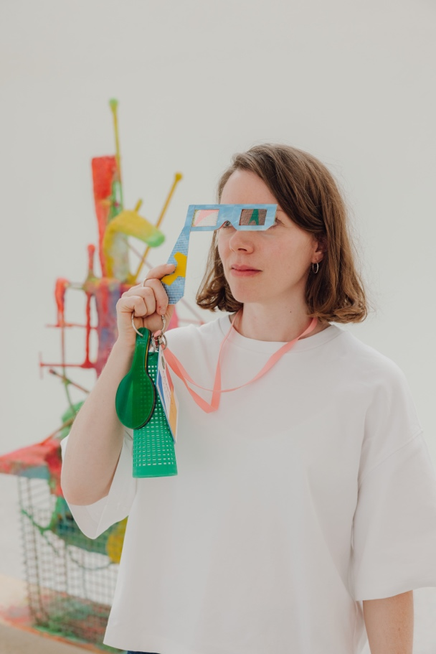
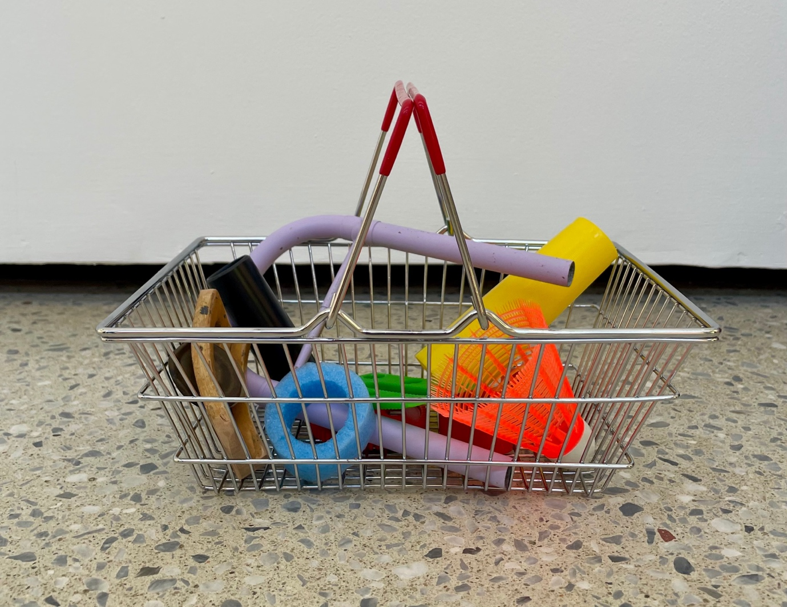

You will also find a range of Accessibility Resources in the gallery.
These include;
- Ear defenders for all ages
- Fidget toys
- Coloured overlays
- Sand timers

Visit our Accessibility Page at ysp.org.uk/visit-us/accessibility to find out more information about Accessibility across YSP.
If you would like to discuss specific access requirements to plan your visit, contact our Information Desk Team on 01924 832631 or email us at info@ysp.org.uk.

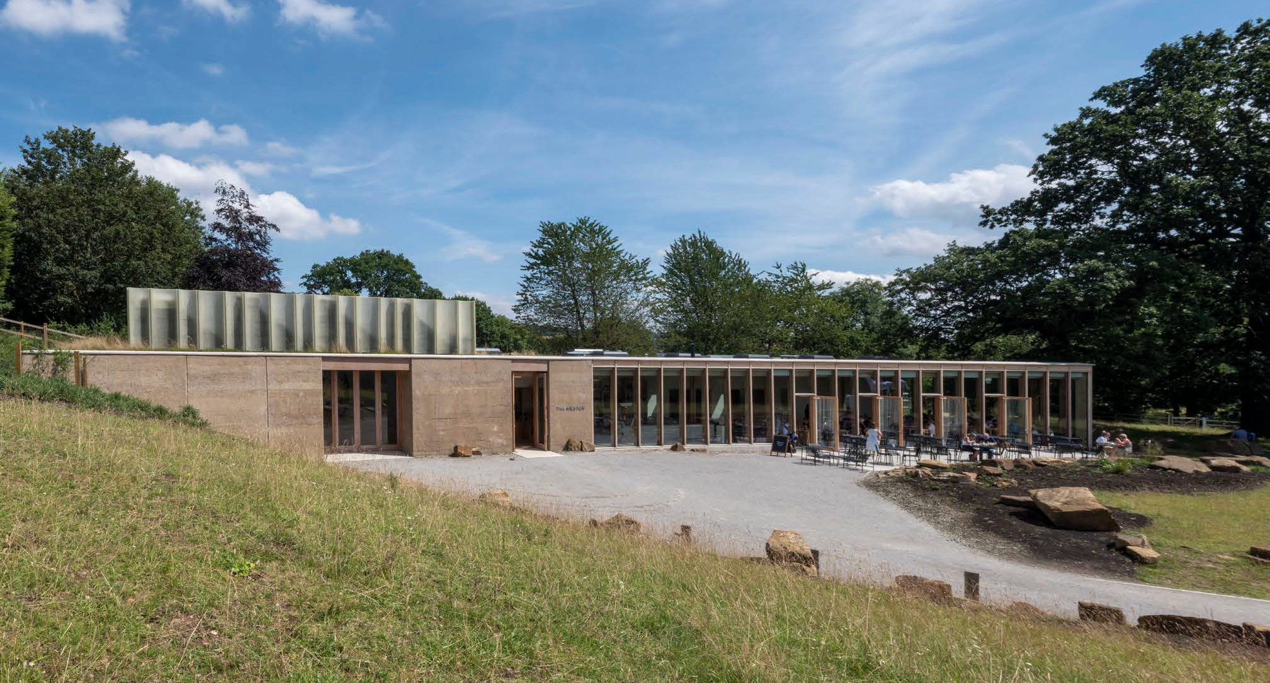

About The Weston Gallery

Opening Hours

The Weston Gallery is open Tuesday – Sunday from 11.00 until 16.00
(and on Mondays during Wakefield School Holidays and Bank Holidays)

Gallery Guidance

Entry to The Weston Gallery is free.
Explore the exhibition without touching the artworks.
Photography is permitted.
No food or drinks are allowed inside the gallery.
Assistance dogs only.
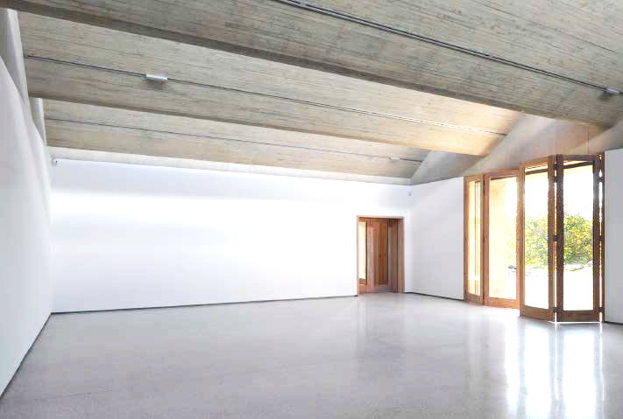

Inside The Weston Gallery

The Weston Gallery is located inside The Weston, a building at the eastern edge of YSP, which contains The Weston Restaurant, Gallery and Shop. The Weston is a single-storey building which is step-free throughout.

The Weston Gallery is one large room. The gallery is lit with both natural light and artificial light. Large glass doors on one side of the gallery look out on to the YSP landscape, and skylights in the ceiling bring natural light in from above. The gallery is step free and has a polished terrazzo floor.

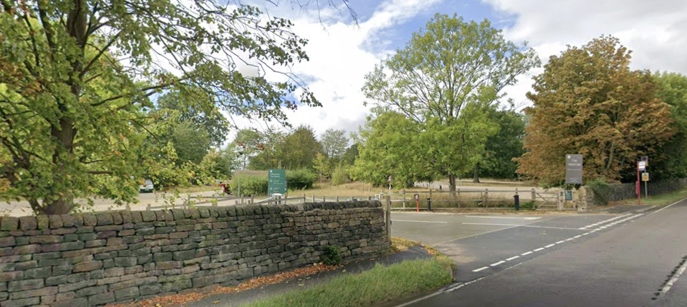
Finding the Weston

Begin your visit to YSP at The Weston –
The Weston can be accessed via its own entrance on Huddersfield Road. This is the first YSP entrance you will pass by car if approaching from the motorway.

As you enter The Weston from this side, you will pass by gender-neutral toilets on your left, and a shop on your right. The restaurant is accessible down a ramp on the far left, and the gallery is located through a set of double doors on the far right.
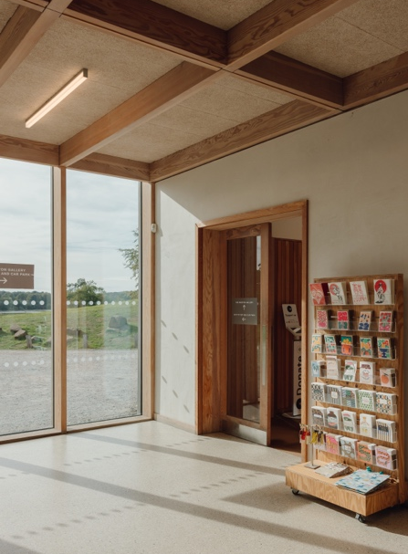
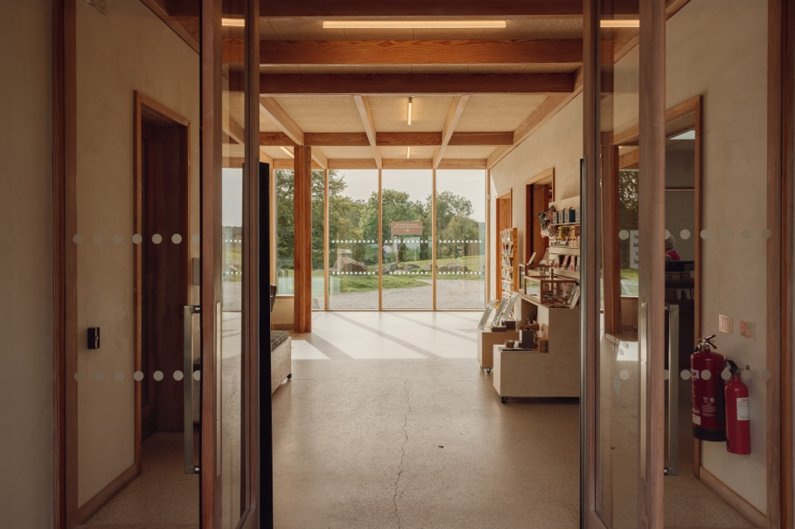
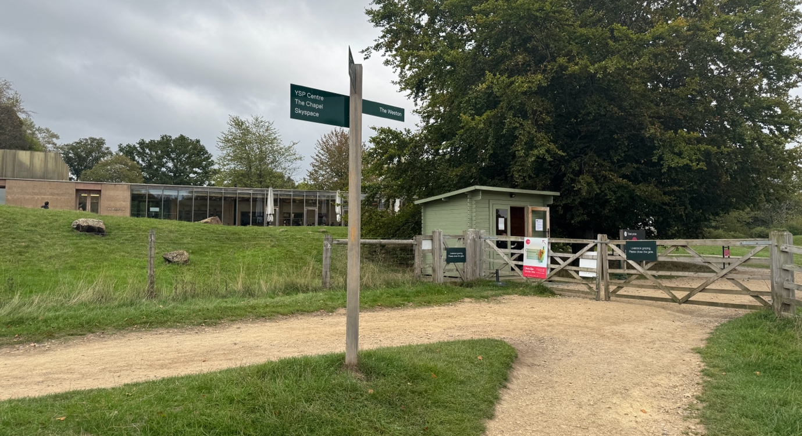

Find The Weston during your visit to YSP –
If you are already in the Park, The Weston can be found by following the path from YSP Centre. Follow signposts through the Country Park to find your way. It is approximately a 15-minute walk from YSP Centre down a steep incline. Pathways are comprised of loose gravel and grass. Off-road mobility scooters can be hired for free from the Information Desk.

Use the YSP Map or ask a member of YSP Staff to find your way.

Ticket Information

Admission to The Weston, including The Weston Gallery, is free and does not require a YSP General Admission Ticket.

Should you wish to explore the rest of YSP after your visit to The Weston, tickets can be purchased from the Ticket Shed as you enter the park, or via the YSP website.

