Exhibition Access Guide

Marshmallow Laser Feast
Of the Oak

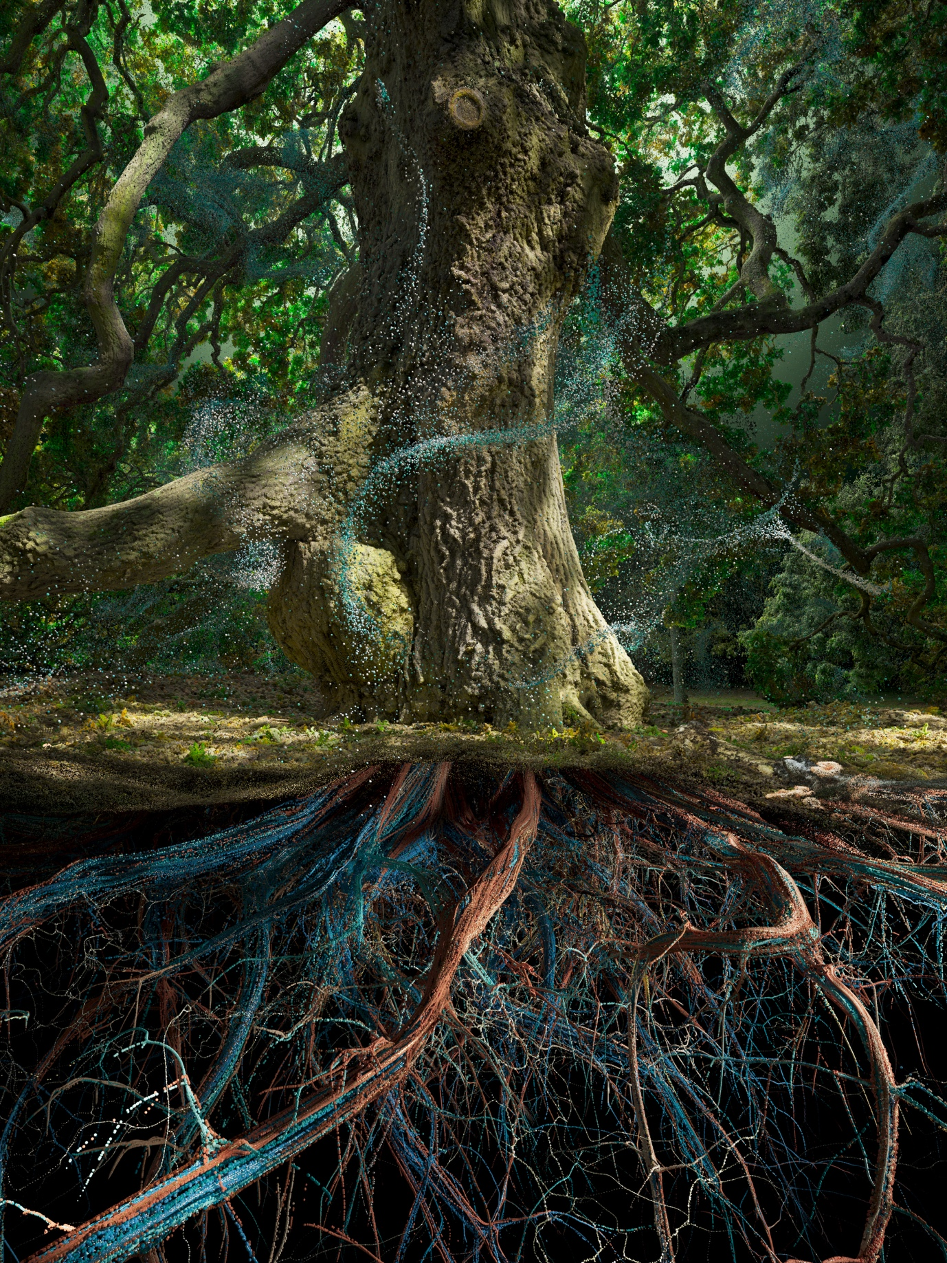
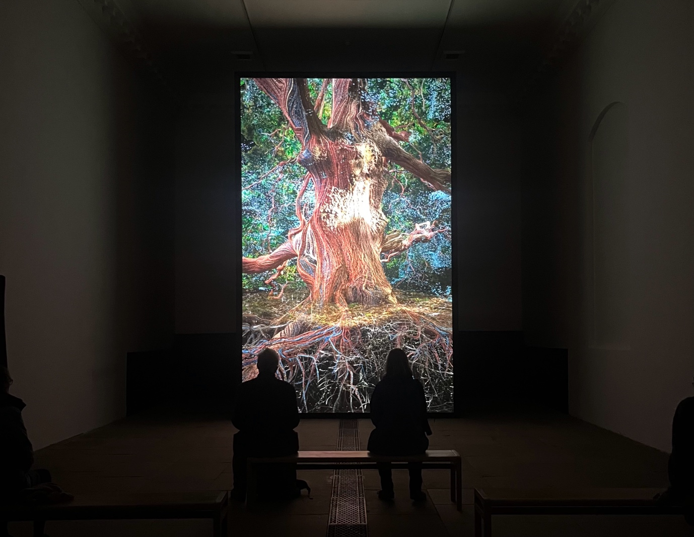
About the Exhibition

Of the Oak is the latest exhibition in the Chapel at Yorkshire Sculpture Park. It is an exhibition of artwork by artist collective, Marshmallow Laser Feast. The exhibition centres around one artwork. Of the Oak is a 12-minute video installation with multichannel audio that plays on a continuous loop.

The video celebrates the life of an oak tree and the enormous ecosystems of life that it supports. A single oak tree provides shelter and food for more than 2,300 forms of life. The video follows the oak tree through the seasons.

The video is accompanied by a soundscape that combines a classical piano with field recordings of the oak tree, capturing the sounds of some of the many species which call the oak tree home.
Opening Hours

The Chapel is open Tuesday – Sunday from 11.00 until 15.30
(and on Mondays during Wakefield School Holidays and Bank Holidays)

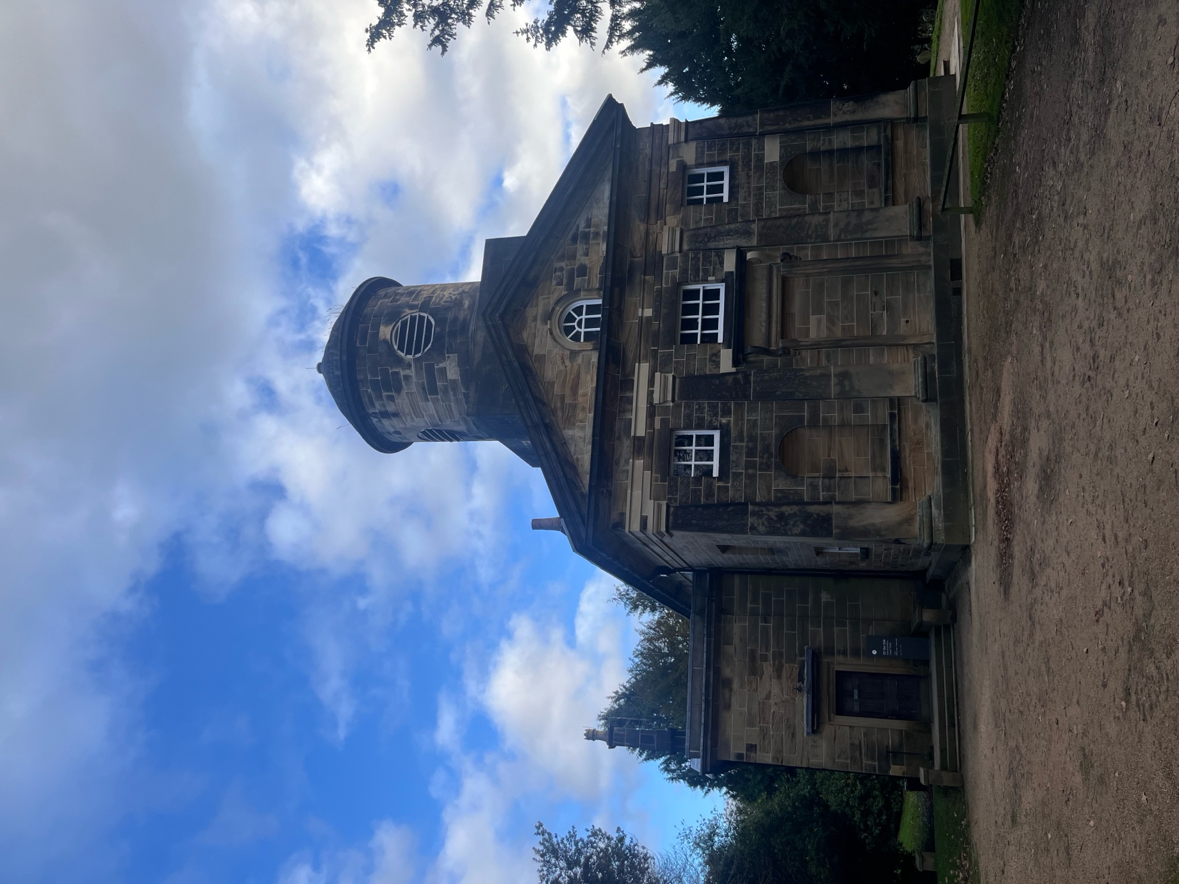

Finding the Chapel

The Chapel is located in YSP’s Country Park. It is approximately a 10-minute walk from the YSP Centre. The path is step-free but not paved, with a moderate slope on the way and an incline on the return.

The Chapel is surrounded by a gravel courtyard and a small graveyard.
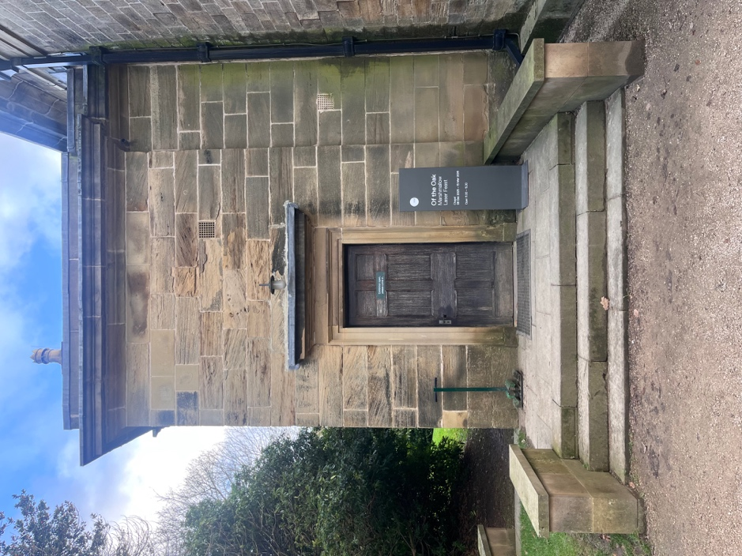
The Chapel entrance can be accessed via three stone steps, or step-free access is accessible via the grass ramp (as shown below).

Due to the size of the doorways in the Chapel, YSP off-road mobility scooters cannot enter the building. Please ask the member of the staff inside the Chapel, if you would like to use a manual wheelchair during your visit.
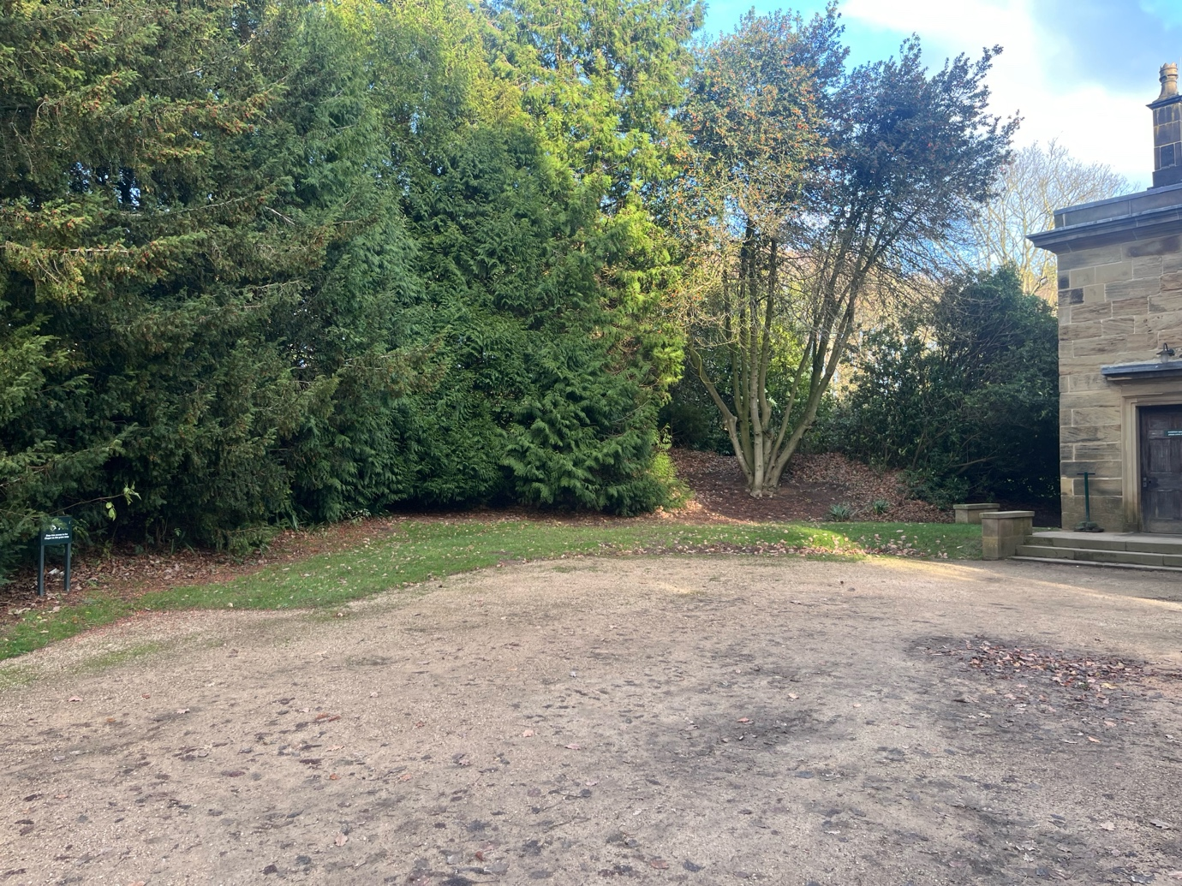
What can you expect inside?
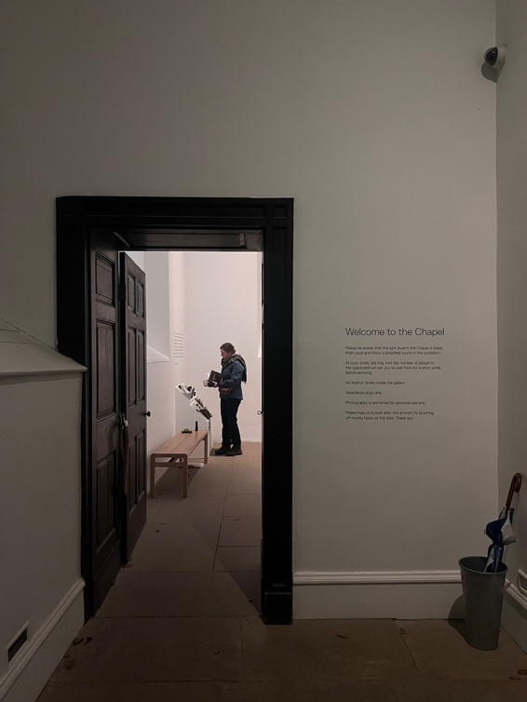
You will enter the Chapel through a small foyer.

You might notice the light is lower than usual. This is to help your eyes transition between the bright daylight outside and the darker lighting in the exhibition.

This exhibition is split between two rooms.

The Organ Pit

The first room you will enter is called the Organ Pit, this room contains information about the exhibition and a selection of resources for visitors to explore.

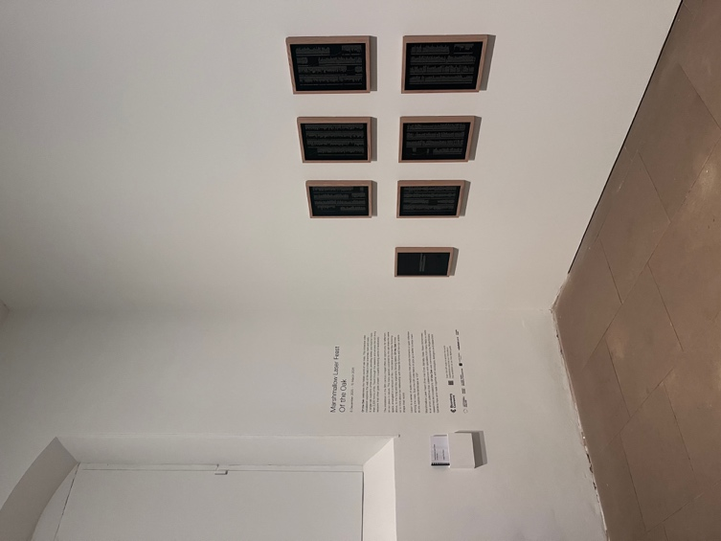
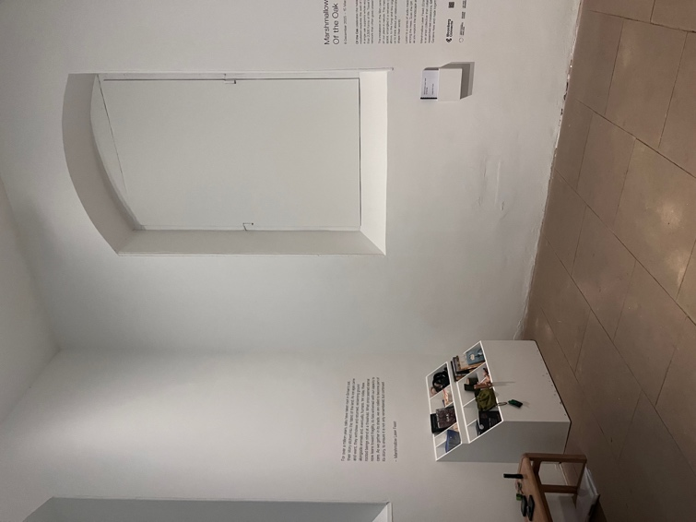

Resources available in the Organ Pit

For each exhibition at YSP, our teams collect and create a range of resources to encourage visitors to explore the themes and ideas of the exhibition more deeply. For this exhibition, the resources are focused on oak trees, nature and wellbeing.

Here’s a list of all of the resources you can find in the Chapel for this exhibition.

- Books for all ages

- Pencil cases with drawing and colouring pencils (the exhibition leaflet has lots of space to write and draw)

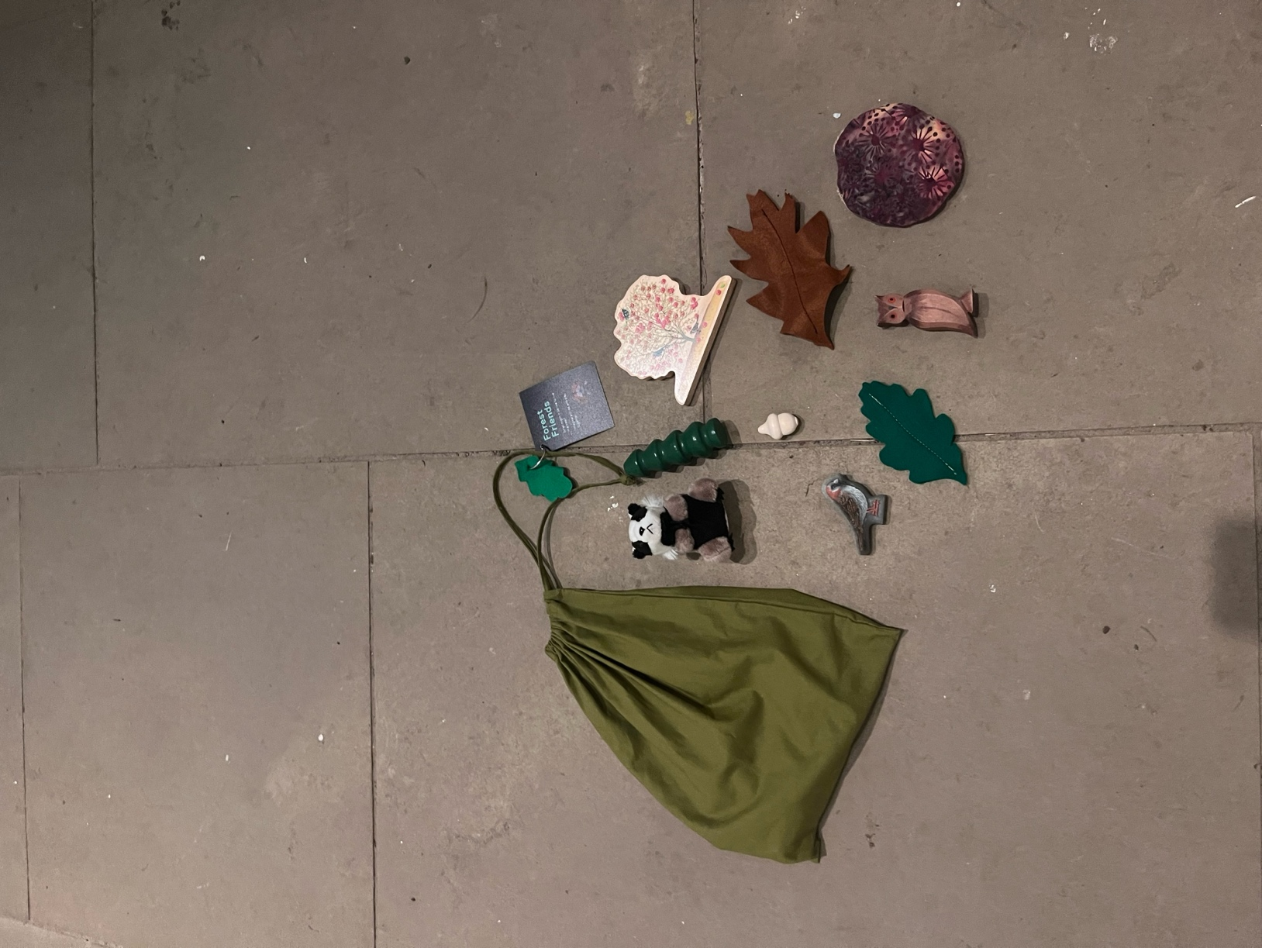
- Green Bags
These bags are full of tiny sculptures, puppets and toys to play and tell stories with.

- Handling materials include oak tree branches and acorn caps
You will also find a range of Accessibility Resources in the Organ Pit.

These include;
- Ear defenders for all ages
- Fidget toys
- Coloured overlays
- Magnifiers
- Sand timers

An introduction to the exhibition is printed on the wall. This text is also available in the following formats;
- Large print
- Braille
- Audio (you can listen to this via a QR code on your own device, or you can ask a member of staff to listen on the iPad in the gallery)

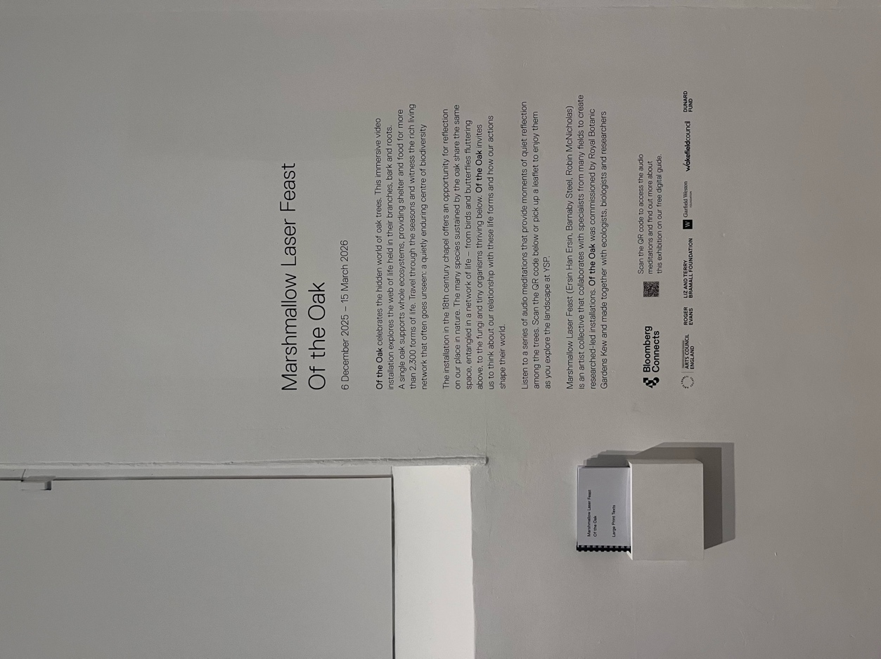

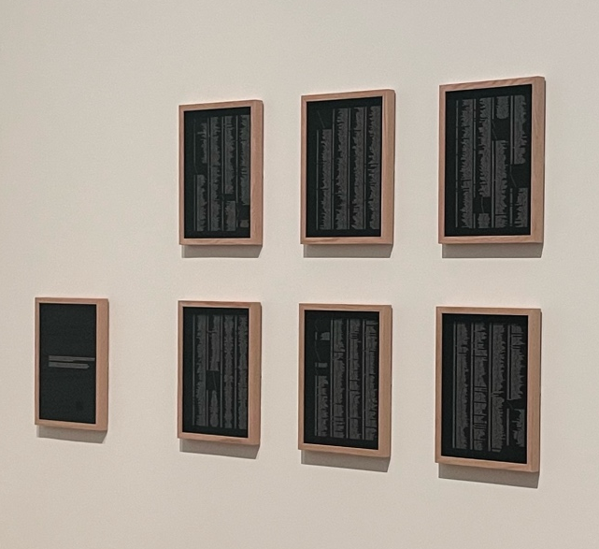
On one wall of the Organ Pit you will find a series of framed prints. These prints display a list of the 2,300 different species that call an oak tree home. Because there are so many species, the text is very small. There are magnifying glasses available if you would like a closer look at the list.

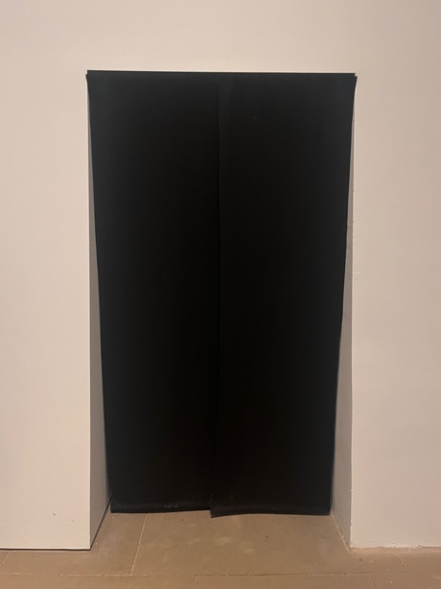
The entrance from the Organ Pit into the main gallery is covered with two layers of black felt curtain. This curtain keeps the light from the Organ Pit out of the main exhibition space. The curtain opens at each side and through the middle for visitors to pass through.

You will use this doorway to enter and exit the exhibition.

The Gallery

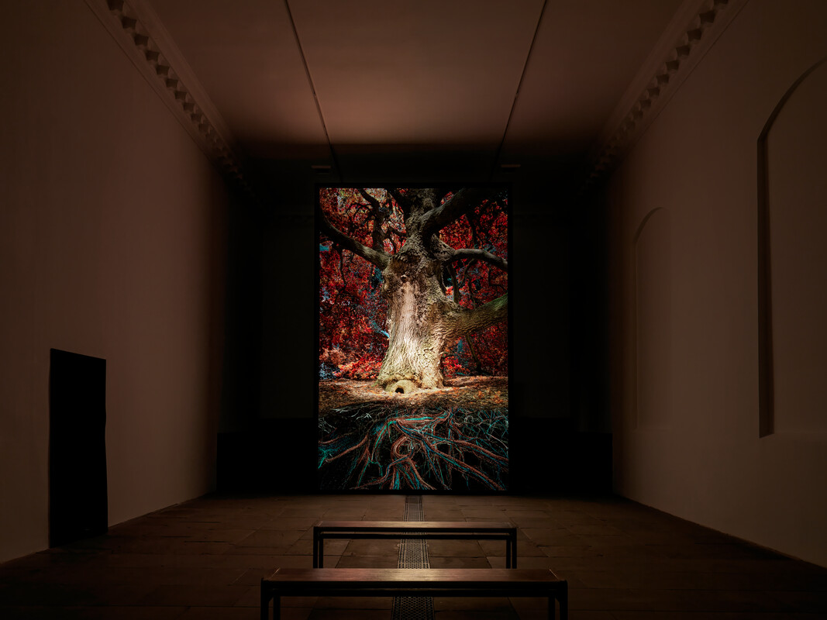

The main gallery is a large room with stone flooring and tall white walls. For this exhibition, all windows in the gallery have been covered.

Of the Oak is displayed upon a 6-meter-high screen which stands at one end of the gallery.

Visitors are invited to spend time in the gallery, watch the installation and explore the available resources.

There are benches available on the ground floor and pew seating available on the balcony.

The Balcony

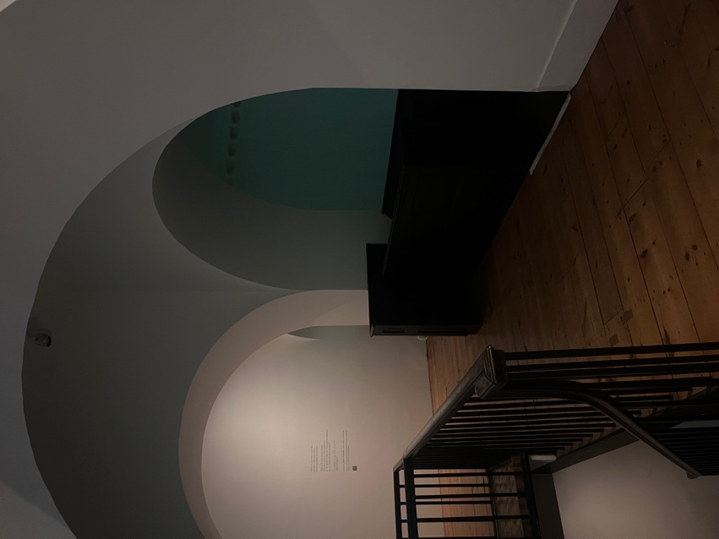
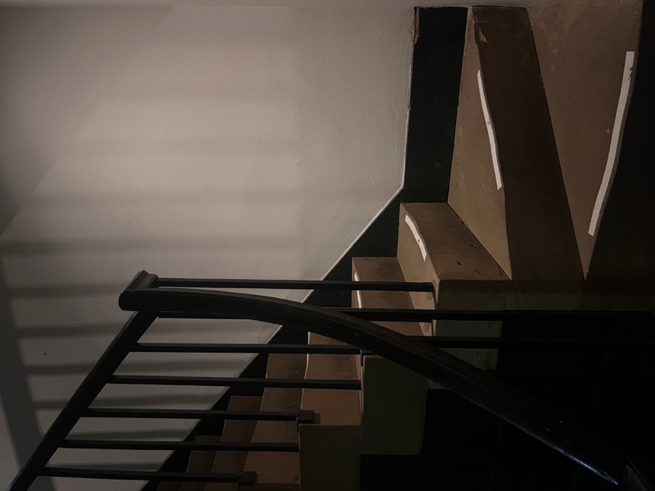
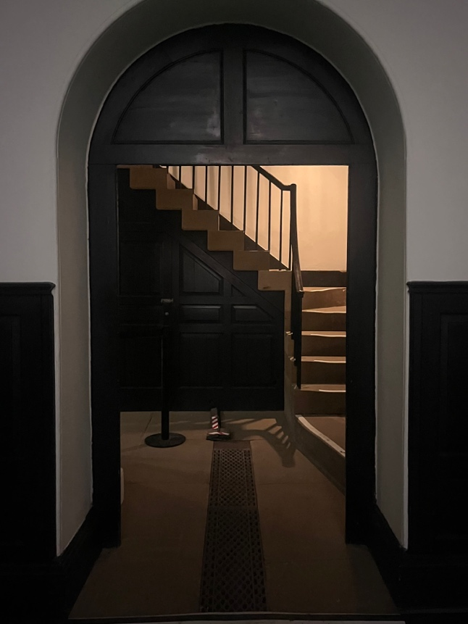

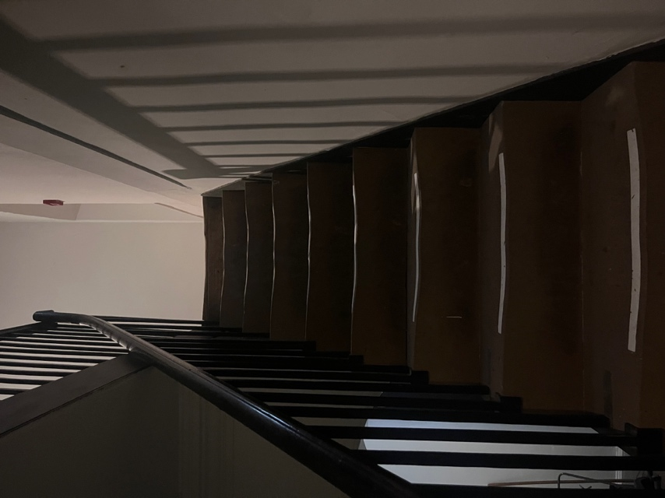
At the back of the gallery, there is a single flight of 18 steps which lead upstairs to the balcony.
Lighting

Light levels are lower than usual in the Chapel for this exhibition.

As you enter the Chapel, the first room you will pass through has slightly dimmer lighting to allow your eyes to adjust as you come in and out of the main gallery space.

The only light source in the main gallery space comes from the film itself, this soft, low light allows you to find your way around – a bit like a cinema.

The light is particularly low on the balcony, please take care in this area.

Sound

The soundscape is amplified throughout the gallery.

Ear defenders are available in the first room, help yourself.

For general accessibility information all other YSP buildings, visit ysp.org.uk/visit-us/accessibility or download our Detailed Accessibility Guide.

