Bharti Kher: Alchemies
Accessibility Guide

Alchemies is an exhibition of artwork by Bharti Kher, on display between 22 June 2024 – 27 April 2025. The exhibition comprises mostly of sculpture, and spans across the entire Underground Gallery. The exhibition also includes four outdoor sculptures which are sited in the surrounding gardens.

The exhibition explores themes of transformation, myth, the female body and the female experience – particularly from a South Asian perspective.

Content Warning

The exhibition features sculptures of unclothed women’s bodies in Galleries Two and Three.

Access Information

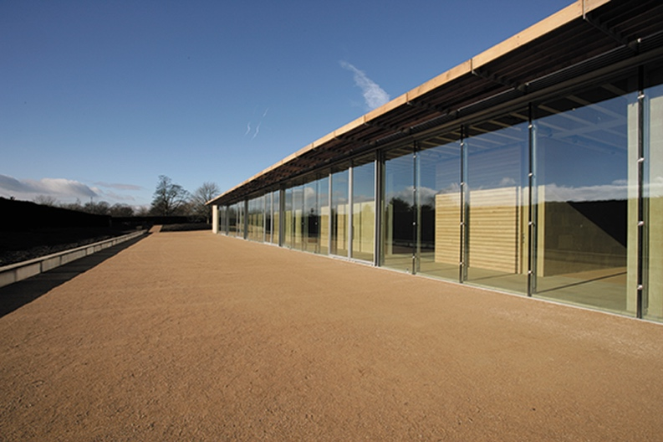
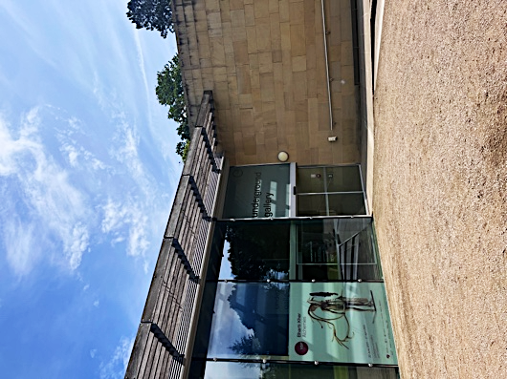
Underground Gallery
Entrance/Exit of the Underground Gallery
The Underground Gallery is on ground level only, with step-free access throughout.

There are benches throughout the gallery.

There are always YSP staff located in the galleries, should you need them.

There are no public toilet facilities in the Underground Gallery. The nearest facilities are located in the YSP Visitor Centre and Bothy Garden, both are a short distance away.

Assistance dogs are permitted throughout the gallery.

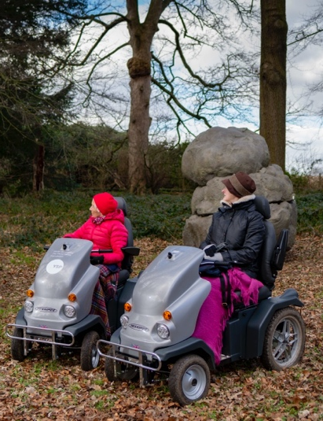
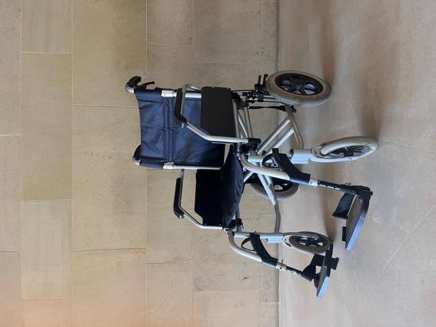
Manual wheelchair available to borrow
YSP off-road mobility scooters

Visitors are welcome to use their own electric mobility scooters throughout the galleries. However, YSP off-road mobility scooters are not permitted inside the galleries due to their size.

There is a manual wheelchair available to borrow during your visit inside the gallery, should you need one.

Accessibility Resources

All of the following resources are available for this exhibition.
If you would like to make use of any of them, just ask a
member of YSP staff.
- Large Print interpretation
- Braille interpretation
- Coloured transparencies for reading
- Ear Defenders (these are also available at the YSP Information Desk)
- Timers
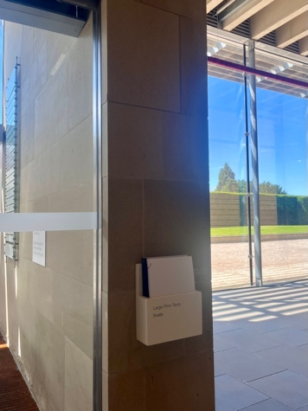
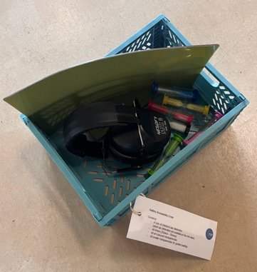
Large Print and Braille interpretation is available in the Foyer
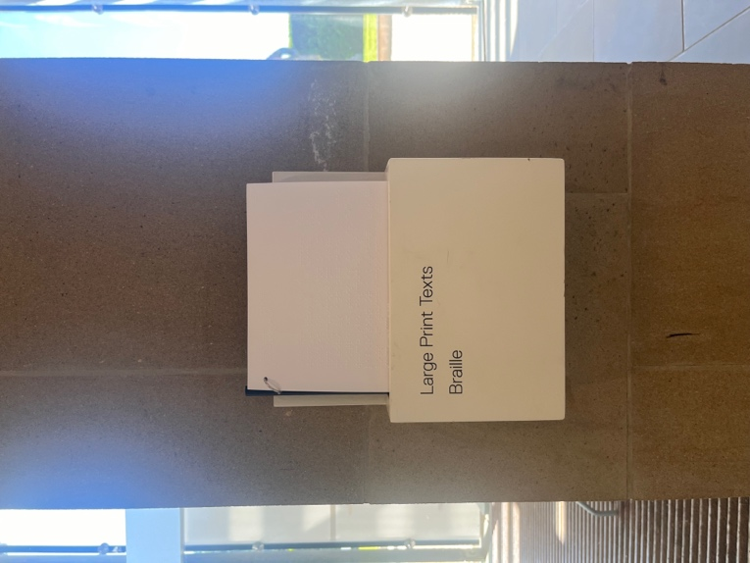
Crate of accessibility resources

Handling Materials

Handling Materials are always available in the galleries for visitors to explore. The objects on the Handling Material trolley are examples of materials used in the exhibition. The artwork in this exhibition is too delicate to touch, so these materials are available for visitors to feel and hold instead.
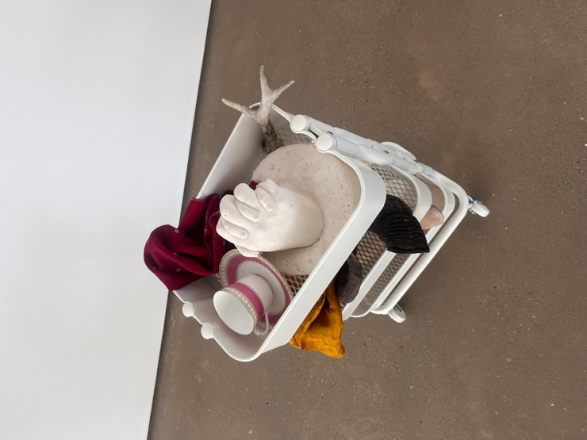

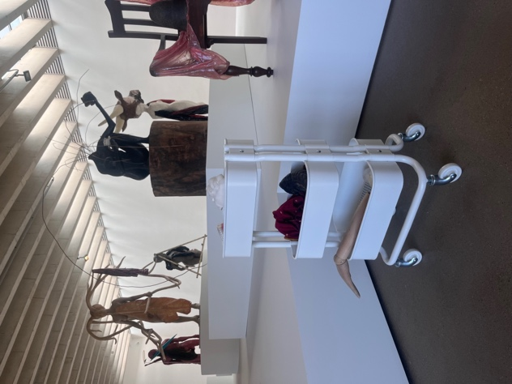

Handling Material Trolley

Family Resources

Our Activity Baskets, Talking Together and Drawing Together cards are designed to encourage sensory exploration of the exhibition for all of our visitors. These are available to collect in the Foyer and take around the gallery as you go.

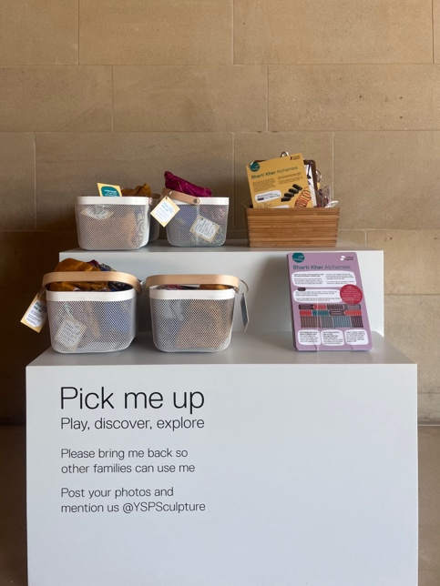
Talking Together (Purple) and Drawing Together (Yellow) cards
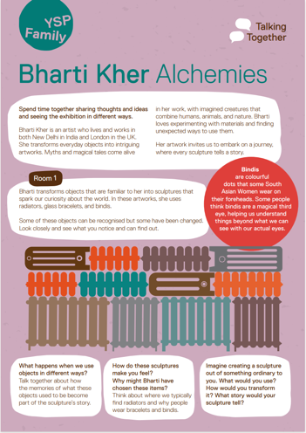
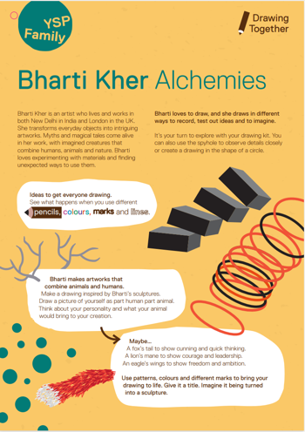
Resources available in the foyer

The baskets contain different activities designed to encourage visitors to explore the exhibition in different ways. In each basket there are four activities, their contents and instructions are below

Seek Me Out  [contains flash cards with images of objects featured in the exhibition}  Go on a sculpture hunt  Find me in the gallery | 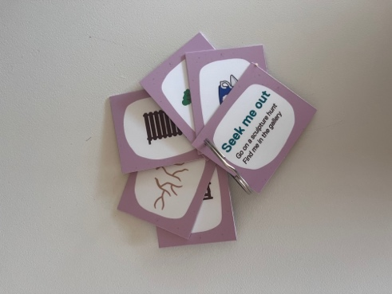
Eye Spy  [contains different objects that can be used as viewfinders to see the exhibition]  Use me to explore.  Look up, look down, look all around.  Seek out details. | 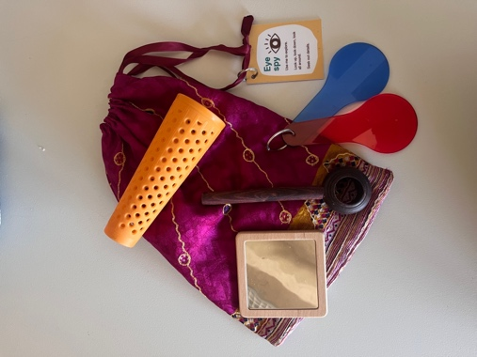
Memory Game  [contains lots of small objects inspired by the exhibition]  Lay out some objects.  Look for 30 seconds.  Cover and remove one  object.  Remove cover.  What is missing?  Try again... | 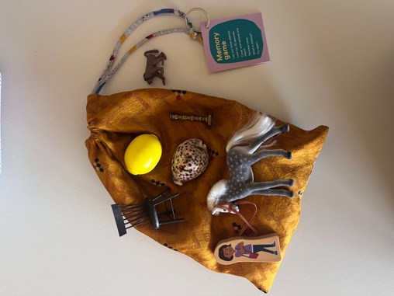
Circles Circles Everywhere  [contains lots of circles of different sizes, made of different materials]  Make patterns with me.  Think about size, shape and material.  What picture can you create? | 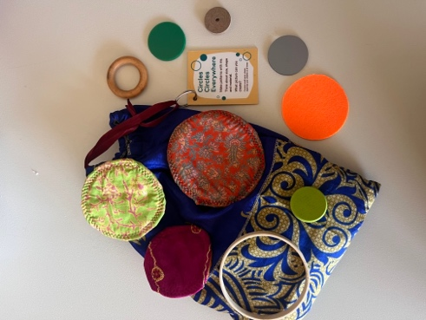

Arrival and Exit
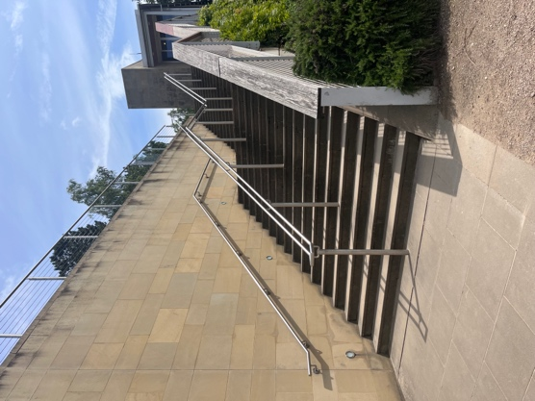
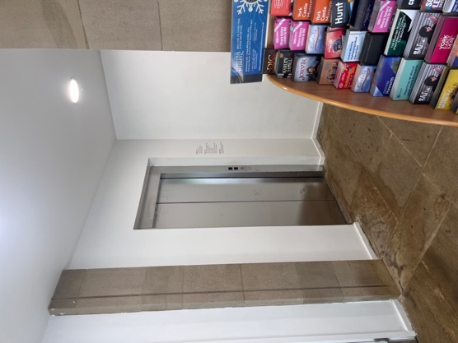
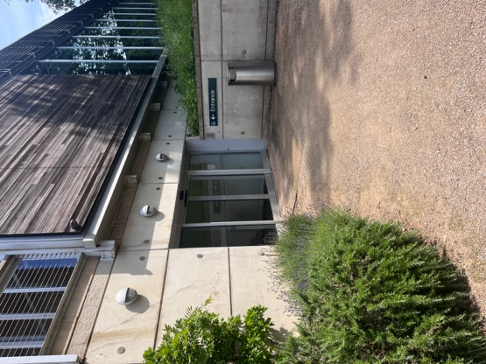
Exiting the lift at Level -1
Lift at Level -1 in the Visitor Centre
Stairs to the Underground Gallery
From the Visitor Centre, the gallery is accessed by a flight of outdoor stairs (32 steps) or internal passenger lift.

Please note that the lift is not large enough to accommodate the YSP off-road mobility scooters. If you are travelling on one of these scooters, you can access the Underground Gallery by following the circular path around the Bothy Garden.

The route from exiting the lift to the entrance to the gallery is outside.

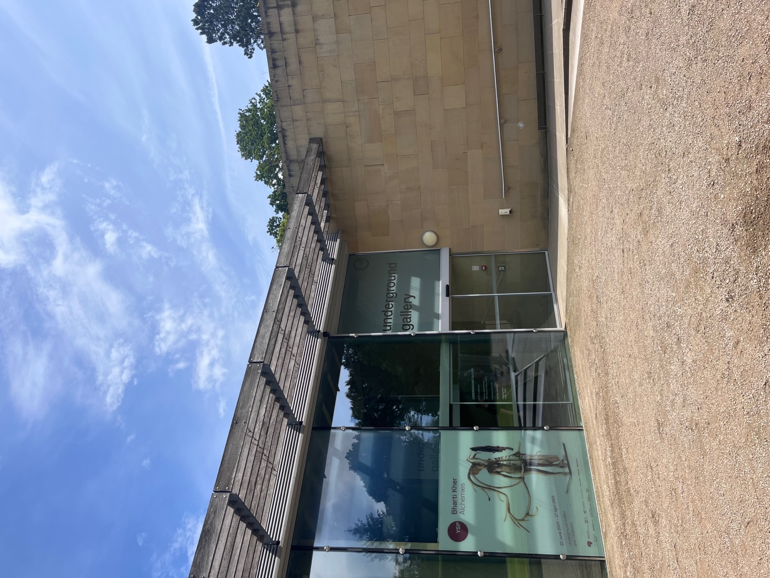
On exiting the lift at level -1, there is a set of sliding automatic doors which lead outside. The width of these doors is 1.5m.

The distance from the lift to the entrance of the Underground Gallery is 57m.

Ramp approaching Entrance/Exit of the Underground Gallery

As you approach the entrance to the Underground Gallery, there is a shallow ramp.

The ground surface is a mixture of compacted, fine gravel and smooth stone slabs. There is a sliding automatic door to the entrance to the gallery with an open width of 2.2m.

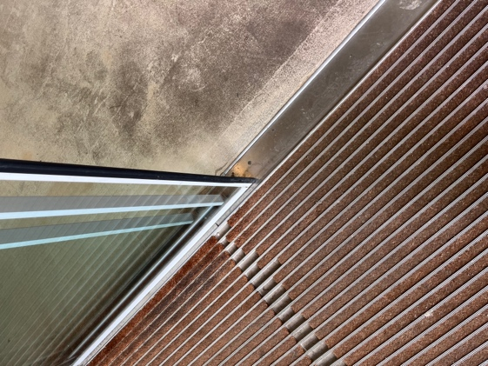
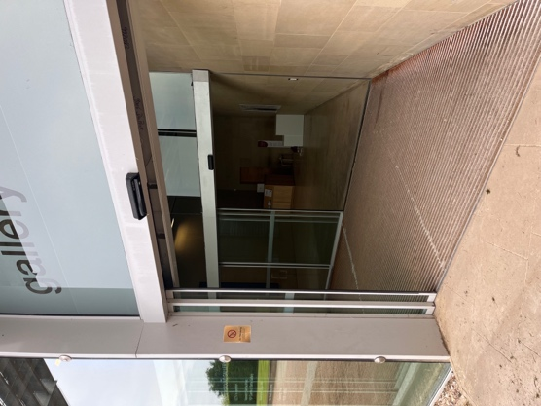

Brush door mat floor within vestibule
Vestibule area

Just inside the entrance is a large, brush door mat. This is the vestibule area.
There is a second sliding automatic door leading into the exhibition area of the gallery. The width of the door is 2.2m.
Entry and exit of the gallery are through the same door.

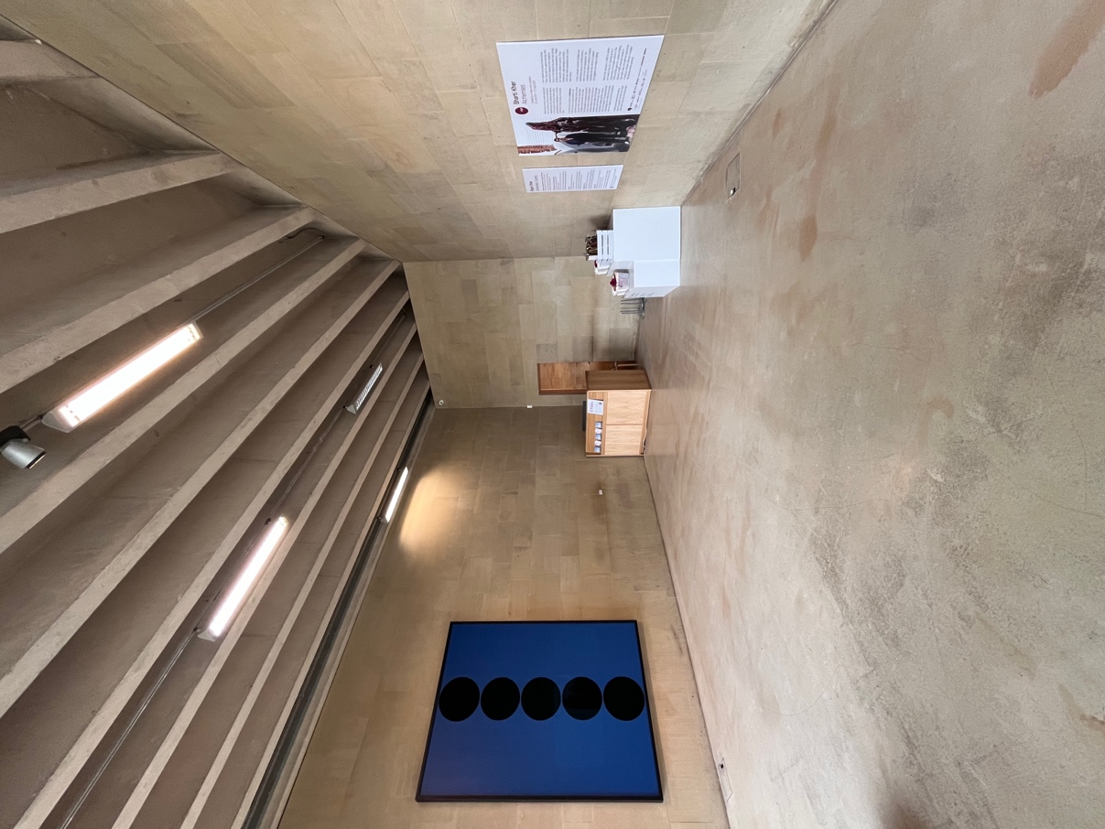
Getting Around

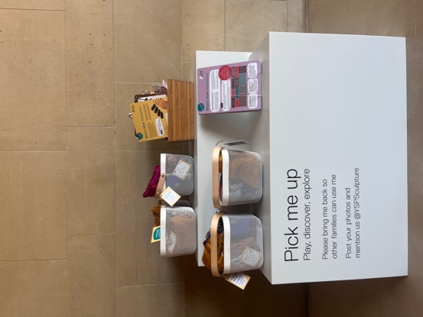
Foyer and Concourse
Family Resources
Foyer
As you enter the gallery, you will enter a foyer area with a desk. There will be information here about the exhibition, and interactive family resources to take around with you.

There is smooth polished concrete flooring in the foyer.

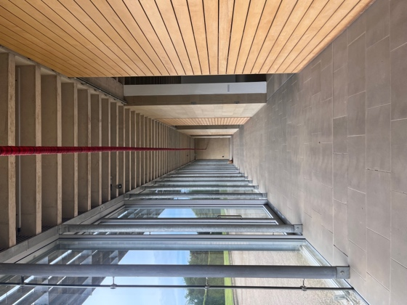
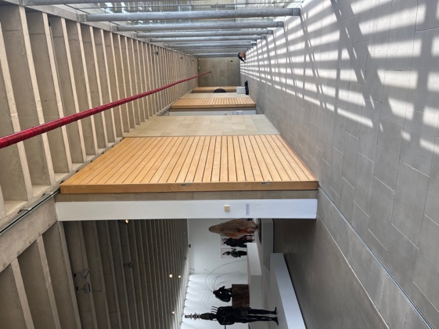
Concourse
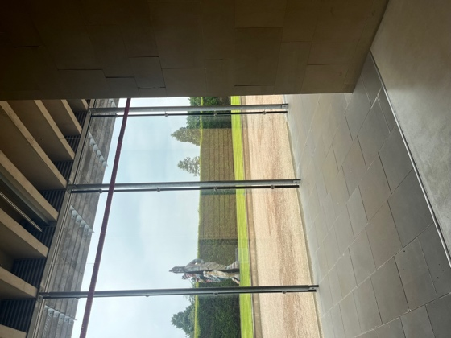

As you proceed around the corner you will find the main concourse. All three gallery spaces run along this concourse on one side. The other side is entirely made up of glass windows, allowing natural light in.

The concourse is paved with large stone tiles.

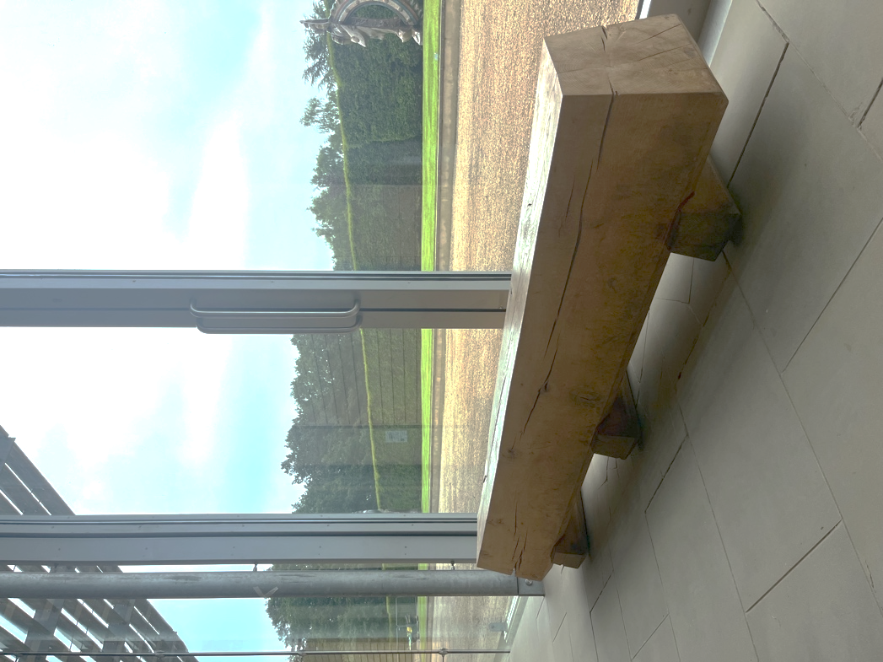
One of two wooden benches located on the concourse
There are two large wooden benches located along the concourse, looking into the galleries. The seat height of both is 41cm.

The Galleries
- There are three gallery spaces within the Underground Gallery.
- All three gallery spaces are lit with both natural and artificial light.
- All three gallery spaces have smooth polished concrete flooring.

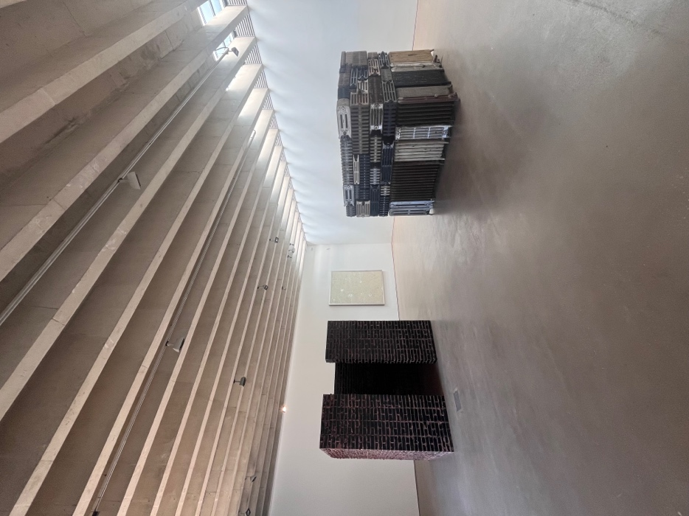
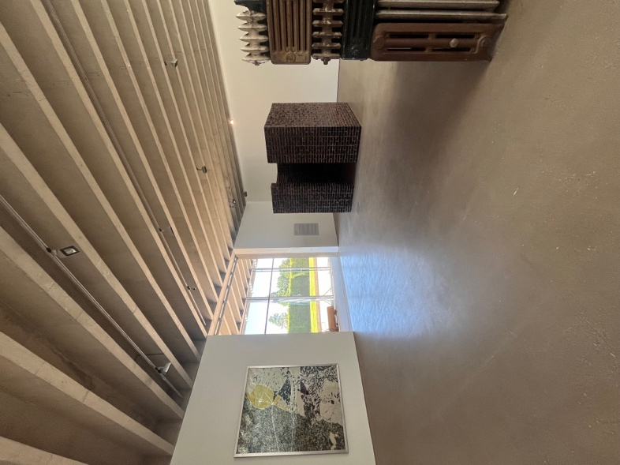
Gallery One

Gallery One

Gallery One contains two large sculptures which can be viewed from all sides. There is plenty of room to move between the sculptures, the narrowest point is 2.4m.
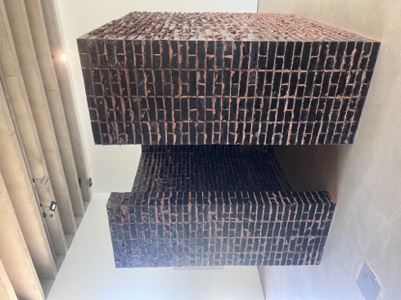
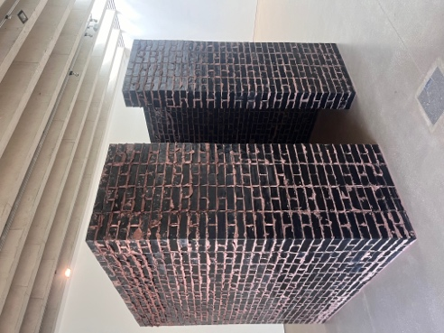
The Deaf Room

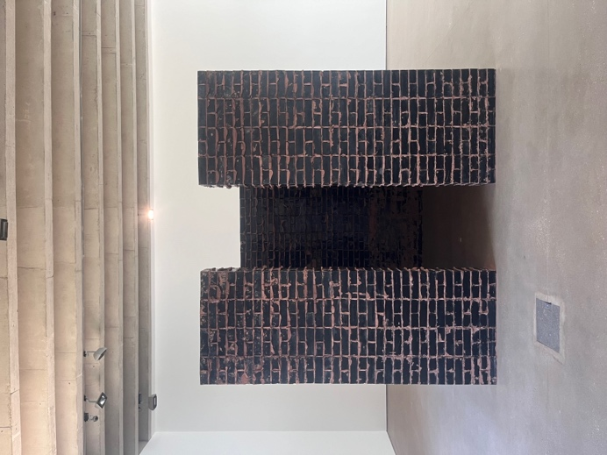

One of the two sculptures in Gallery One is called The Deaf Room, visitors are welcome to enter this artwork if they are able to. The entrance is 0.7m wide. The inside of the sculpture is visible from the outside.

The title of this artwork, The Deaf Room, is a metaphorical reference. The artwork was made in response to the riots that took place in Gujarat, India in 2002 and the widespread violence against women that was taking place at that time. The title refers to the silencing of female voices in this context. Further information about this artwork is available in the gallery and on the Bloomberg Connects app.

There is one open entrance/exit from Gallery One to the Concourse, measuring 3.88m.

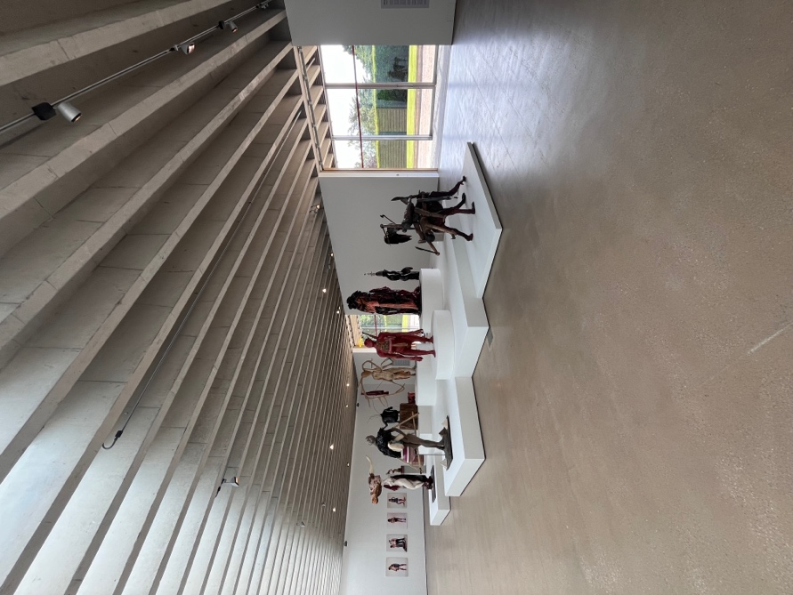
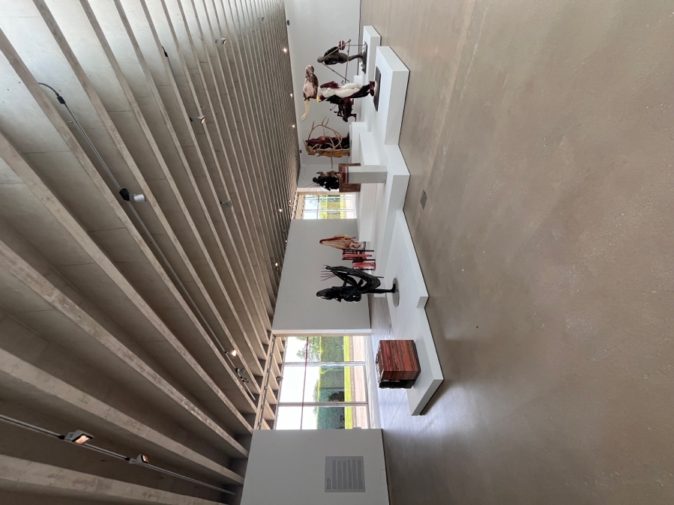
Gallery Two
Gallery Two

Gallery Two presents 14 sculptures upon a large, raised plinth in the centre. There is plenty of room to view the sculptures from all sides of the plinth, the narrowest point is 2.5m.

There are two open entrance/exits from Gallery Two to the Concourse, both measuring 3.88m.

Gallery Three
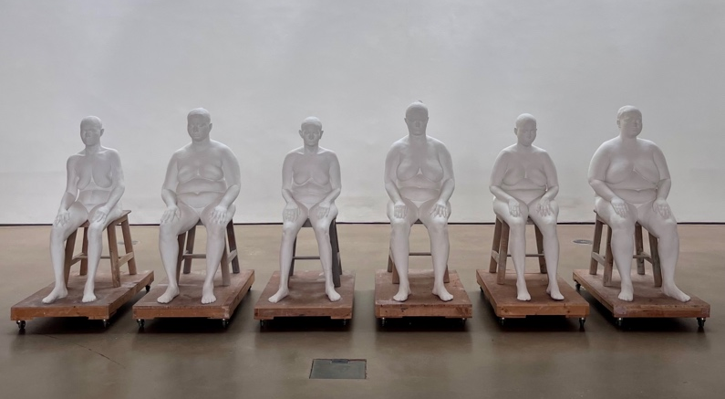
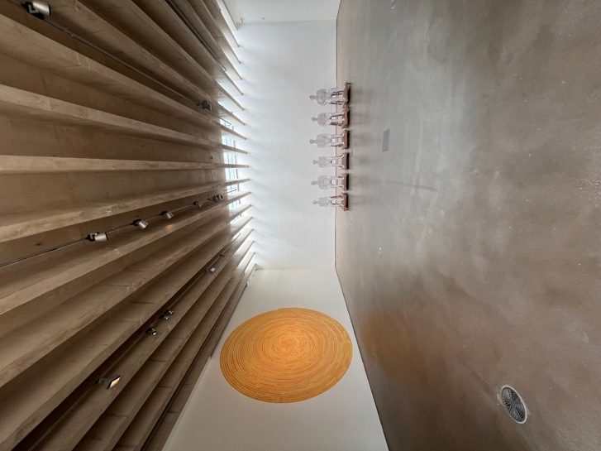
Six Women
Gallery Three

Gallery Three contains one sculpture towards the back of the space. The sculpture, called Six Women, is visible from all angles as there is plenty of room to move around it. The narrowest point is 2.7m

There is one open entrance/exit from Gallery Three to the Concourse, measuring 3.88m.
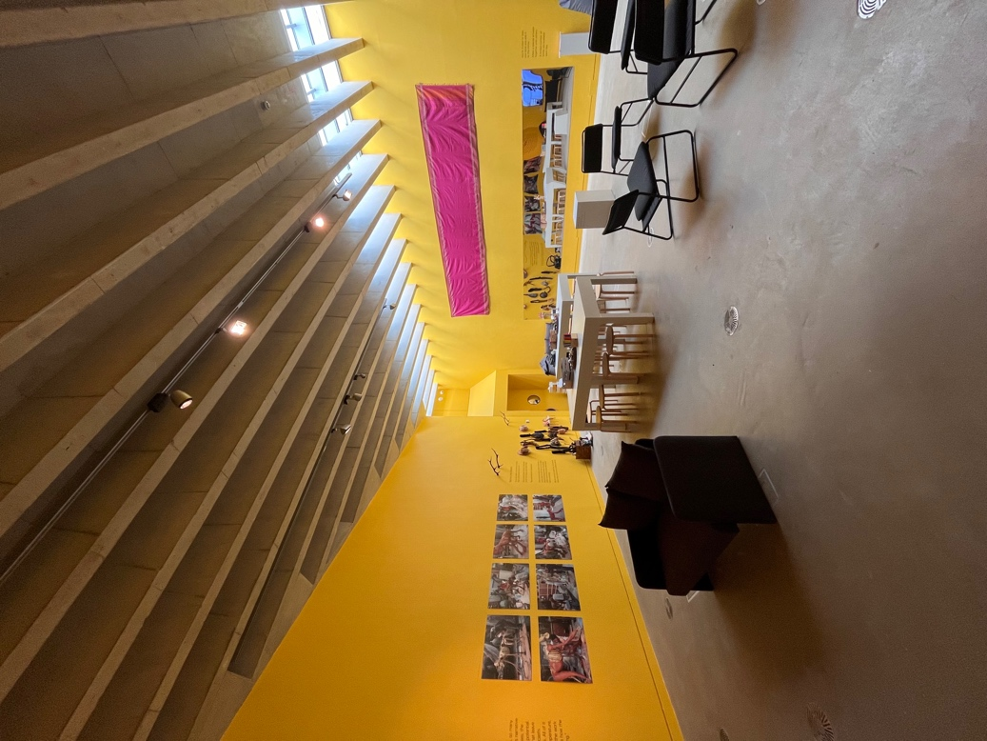
Imagination Station

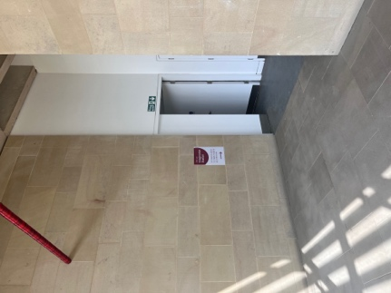

The end of the concourse, leading to the Imagination Station
Imagination Station

When you reach the end of the concourse, turn the corner and you will find the Imagination Station.

In this room you will find interactive activities, books and films for everyone to enjoy, all of which have been selected specifically for this exhibition.

There is plenty of seating here, including stools, benches and beanbags.

