Exhibition Access Guide

Laura Ellen Bacon: Into Being

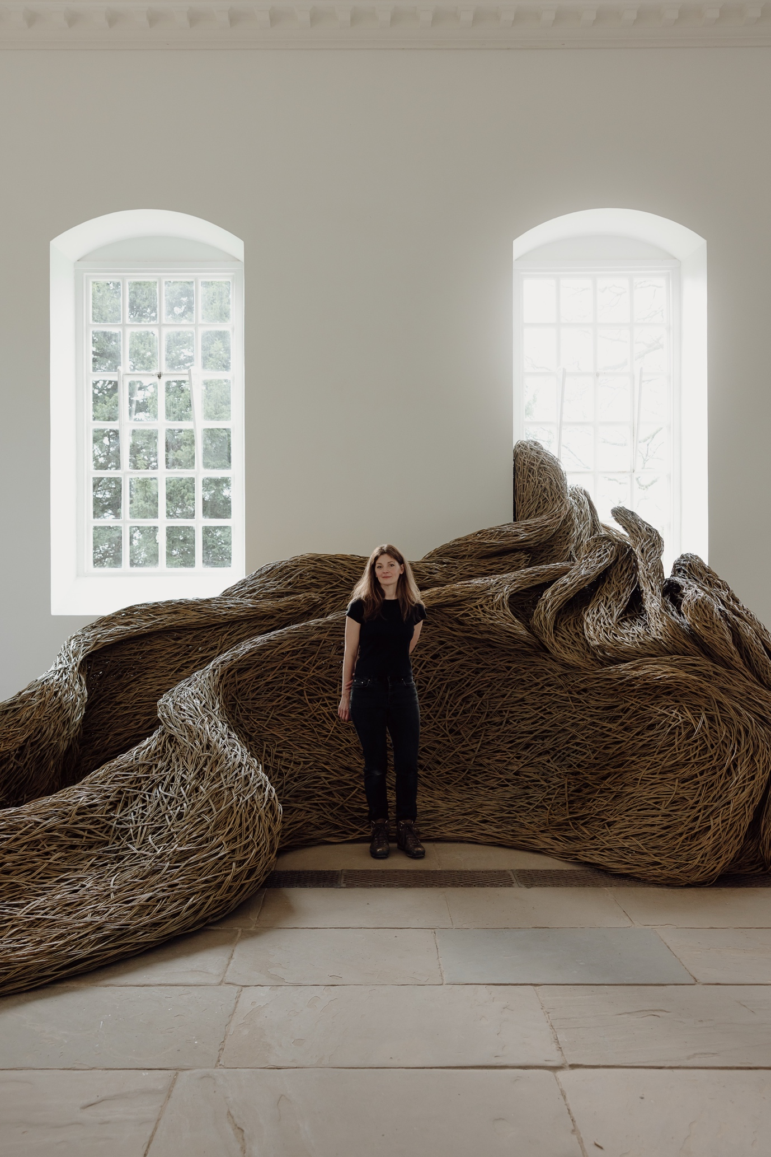

*Into Being* is the latest exhibition in the Chapel at Yorkshire Sculpture Park. It is an exhibition of artwork by Laura Ellen Bacon.

The exhibition takes place throughout the Chapel building, with artwork on the ground floor and the balcony.

The Chapel is open Tuesday – Sunday from 11.00 until 16.00

(and on Mondays during Wakefield School Holidays and Bank Holidays)

What can you expect?

The central artwork in the exhibition is also titled, *Into Being*. It is a large structure made of willow branches. Visitors are welcome to touch the artwork gently to feel the willow.

The artwork takes up a large portion of the gallery space, it is approximately 6.5m long, 5.8m wide and 2.9m high.

The willow forms a nest-like shape, with walls on each side which begin low to the ground and reach up to the window. There is a wide opening at one end of the artwork, measuring approximately 2.5 meters. Visitors are invited to step inside if they wish to.

There are two benches for visitors on the ground floor of the Chapel, and pew seating on the balcony.

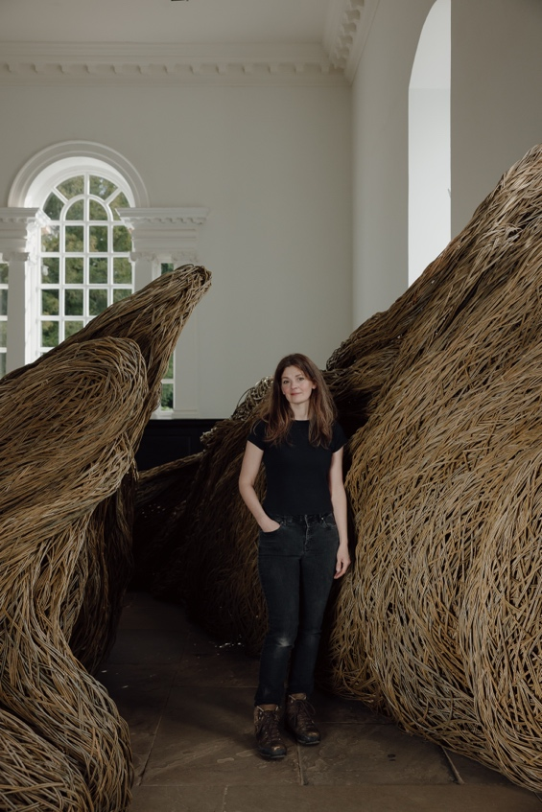

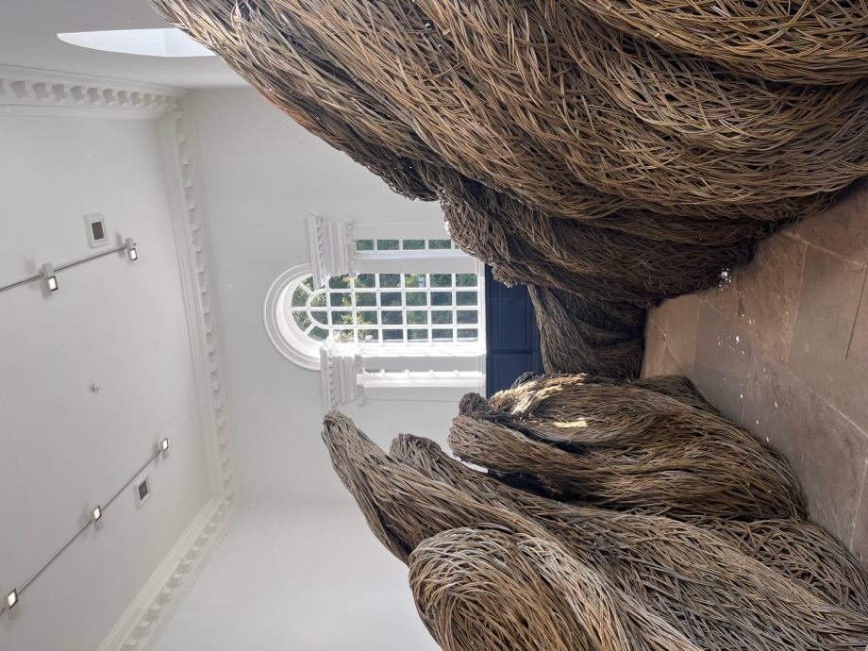

At its narrowest point, the passageway inside the sculpture is 60cm wide.

Elsewhere in the Chapel there are 4 smaller artworks; one as you enter from the foyer area, one in the Vestry (the small room in the corner of the main space), one beside the window as you walk upstairs, and one hung on the wall in the balcony. Also hung in the balcony are three framed drawings.

In the adjoining room, as you enter the Chapel, you will find a TV screen showing a timelapse of the exhibition installation process. Also in this area are various resources to draw and explore the exhibition further.

All written information that is included in this exhibition is available in the gallery in the following formats;

* Large print
* Braille
* Audio via a QR code

For general accessibility information about the Chapel and all other YSP buildings, visit [ysp.org.uk/visit-us/accessibility](https://ysp.org.uk/visit-us/accessibility) or download our [Detailed Accessibility Guide.](https://yorkshire-ysp.files.svdcdn.com/production/Accessibility/YSP-Accessibility-Guide-Dec-2024.docx)