Exhibition Access Guide

Felicity Aylieff: Expressions in the Blue

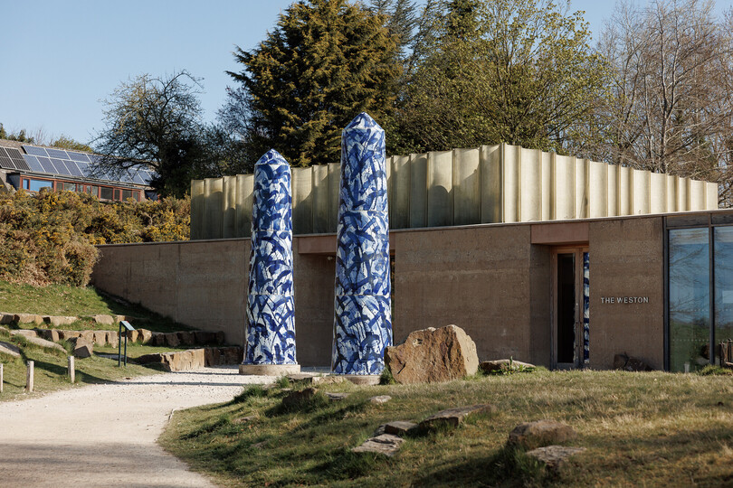

*Expressions in Blue*  is the latest exhibition in the Weston Gallery at Yorkshire Sculpture Park. It is an exhibition of artwork by Felicity Aylieff.

The exhibition takes place in the Weston Gallery and outdoors, with two large sculptures by Felicity Aylieff on display just outside the gallery.

The Weston is open Tuesday – Sunday from 11.00 until 16.00

(and on Mondays during Wakefield School Holidays and Bank Holidays)

What can you expect?

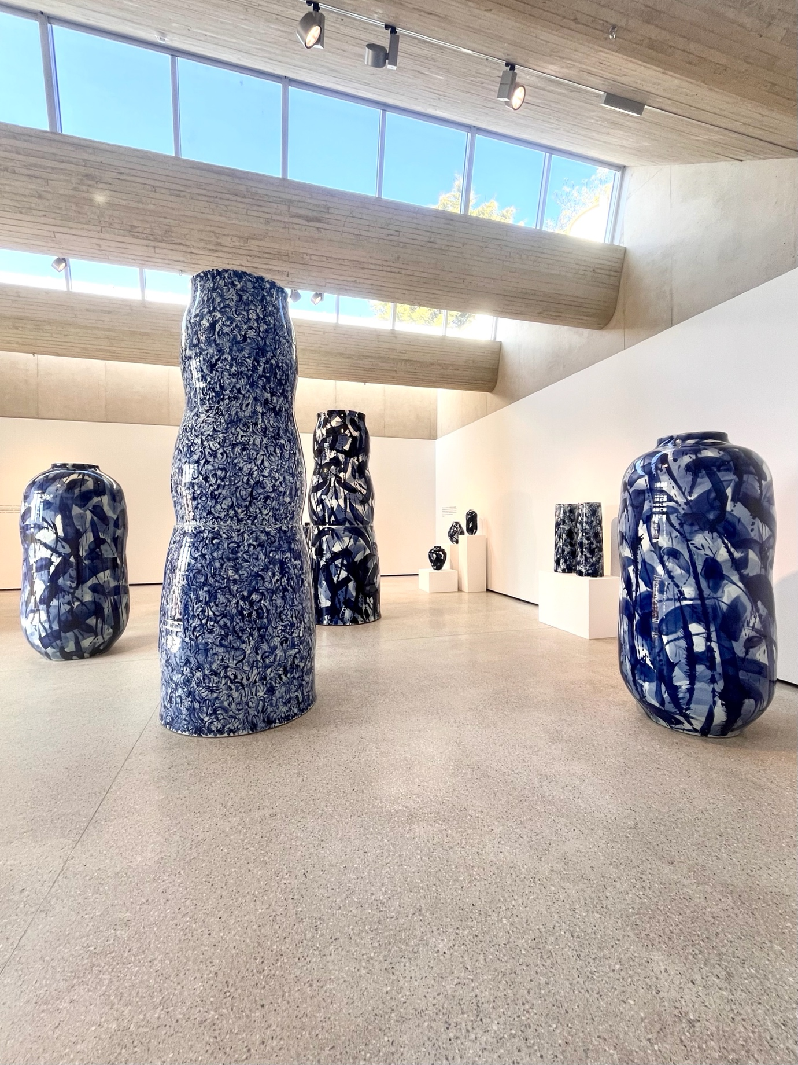

In the Weston Gallery you will find a series of 18 ceramic pots in various sizes, from 40cm to over 3 meters tall. The porcelain vessels are painted in 3 shades of cobalt blue.

The pots are positioned throughout the room, inviting visitors to walk amongst them.

We do not encourage visitors to touch the artworks in this gallery. This protects the delicate glazes on the surface of the pots from scratches and cracks. Instead, we have a selection of handling resources for visitors to hold and feel. Please ask a member of the Gallery Team for these.

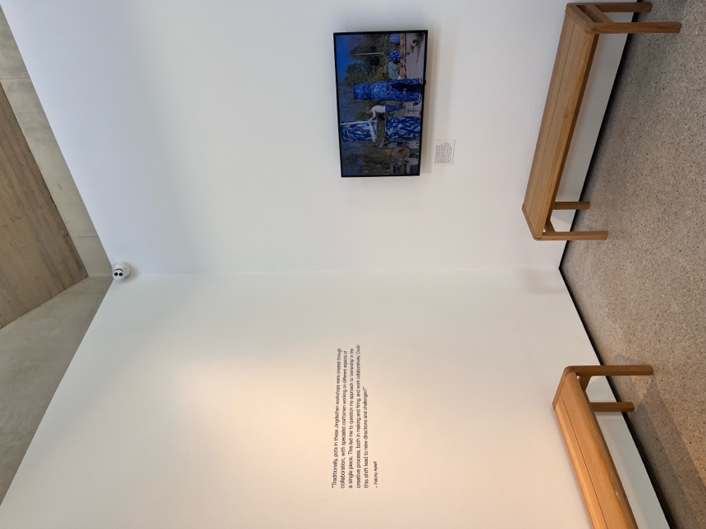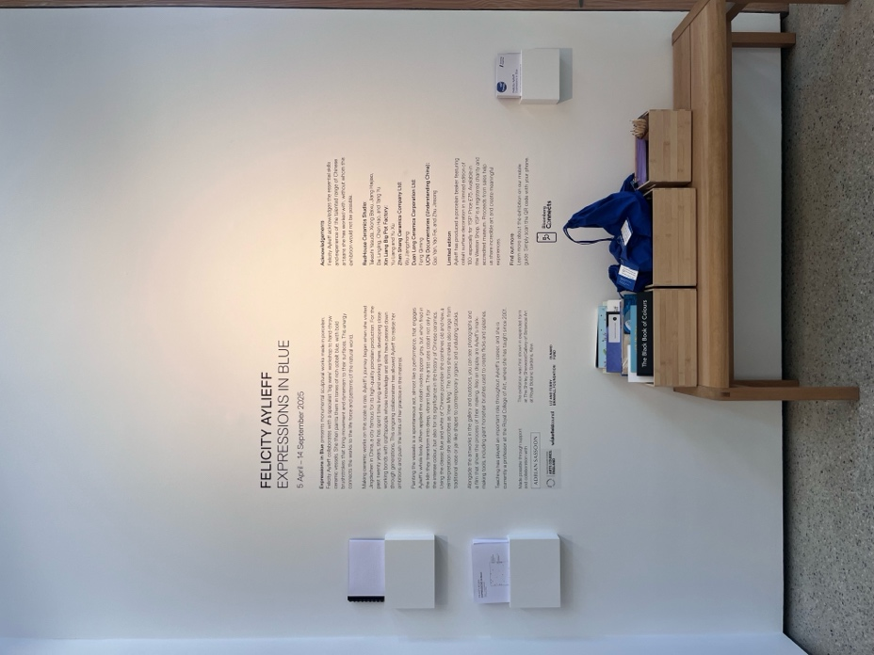

As you enter the gallery, to your left, you will find interpretation text about the exhibition and ground plans which tell you which artwork is which. This interpretation text is available in the gallery in the following formats;

* Large print
* Braille
* Audio via a QR code

In the wooden boxes beneath the text are a collection of resources to draw and explore the exhibition further.

In another corner of the gallery, you will find a TV screen showing a film. This film shows the process of Aylieff making the pots you can see in the exhibition. The film is 14 minutes long and plays on a continuous loop. There is no speech, only gentle music and the sound of artists at work. Benches are available for visitors to sit down while they watch.

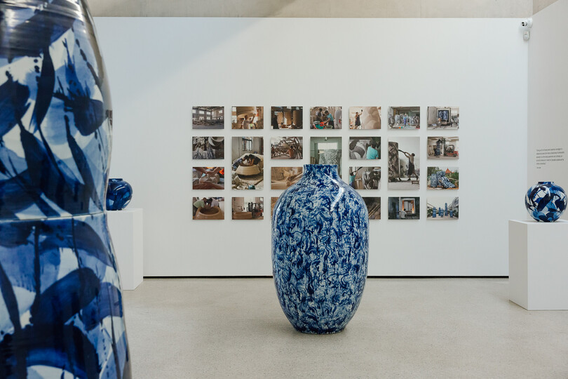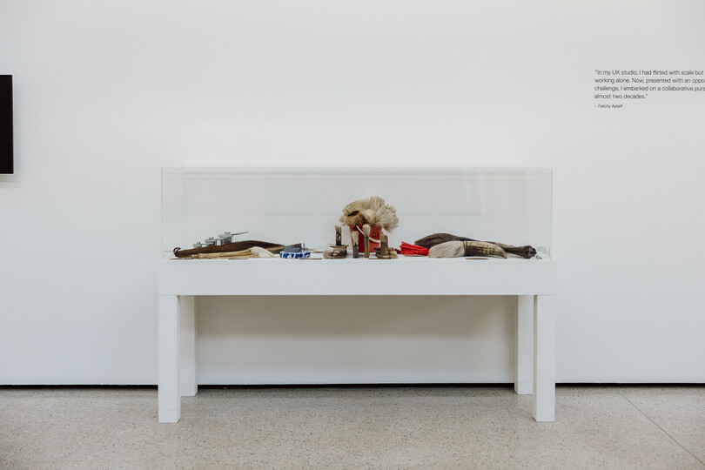

Beside the TV is a display of tools used by Felicity Aylieff to create the pots you see in the exhibition.

In the opposite corner of the gallery, you will find a display of photographs. These photographs document the making process, they show Aylieff and her collaborators making the pots you can see in the exhibition.

For general accessibility information about the Chapel and all other YSP buildings, visit [ysp.org.uk/visit-us/accessibility](https://ysp.org.uk/visit-us/accessibility) or download our [Detailed Accessibility Guide.](https://yorkshire-ysp.files.svdcdn.com/production/Accessibility/YSP-Accessibility-Guide-Dec-2024.docx)