YSP Accessibility Guide
For accessibility enquiries, please contact the Visitor Experience Team:
info@ysp.org.uk
01924 832631

Welcome
YSP is an award-winning art gallery, with indoor and outdoor exhibitions which change throughout the year. The Park is set within the vast grounds of a former Country Estate and offers fantastic views and walks including woodland, country parkland and lakeside trails.
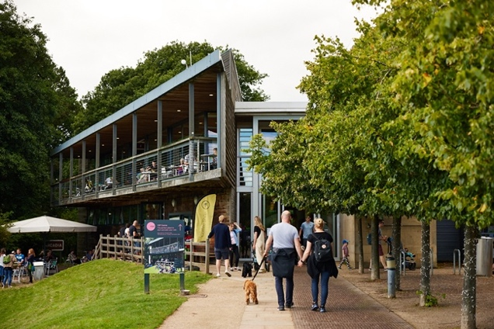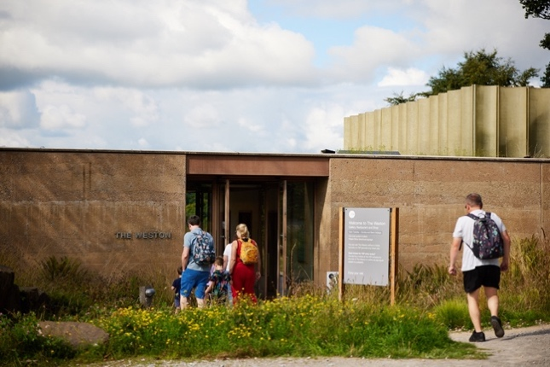
Accessibility at a glance
- Accessible parking
- Level access within main visitor centre, The Weston, and Underground Gallery
- Hearing loop at Information Desk
- Mobility scooters available to hire
- Large print and braille interpretation within galleries
- Friendly staff available in all buildings

Getting here:
Yorkshire Sculpture Park
West Bretton
WF4 4LG
Sat Nav: WF4 4LG
What three words: ///hypnotist.stump.island

YSP is situated on the Huddersfield Road, just off junction 38 of the M1 near the village of West Bretton.

Travel by public transport
There is a regular bus service from Wakefield Bus Station that stops at the entrance to YSP (96 Service). For the latest timetable information visit travelsouthyorkshire.com.

The bus stop at YSP is located approximately 65 metres from the entrance to the main visitor centre.

Travel by taxi
Local taxi services can drop off and collect at YSP. The drop off/collection point is located approximately 65 metres from the entrance to the main visitor centre.

Local taxi services can drop off and collect outside The Weston.

Travel by car/parking
Priority parking for Blue Badge holders is available in the main car park next to the main visitor centre, with 11 spaces available. The furthest Blue Badge space is approximately 35m from the entrance to the visitor centre. You do not need to book these in advance, please park in your preferred space on arrival. The Blue Badge spaces are on tarmac, with dropped curbs and a level access route to access the visitor centre.
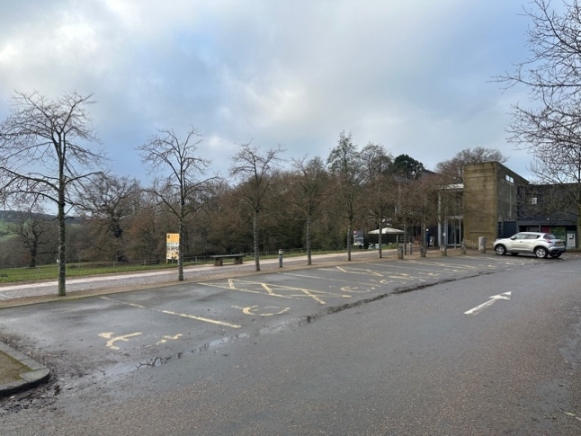
YSP buildings and attractions
YSP is a large site with a number of buildings and outdoor areas. You can explore the Park at your leisure in any direction or route that you would like to follow. You can visit as much or as little as you like. This guide provides access details for each of these main areas:
- Visitor Centre: Information Desk, toilets, café, shop
- YSP Learning Building and Café: Café, toilets, workshop spaces
- The Weston: restaurant, café, shop
- Underground Gallery: indoor art gallery
- Chapel: indoor art gallery
- Outdoor areas:
  - Formal Gardens
  - Country Park
  - Lakeside paths

We recommend starting your visit at the Visitor Centre.

Visitor Centre

Arrival
Path to main entrance of the building:
- From Blue Badge parking to the main entrance of the Visitor Centre, there is level access
- This path is a mixed surface of paving slabs, compressed gravel and engraved metal sheets.
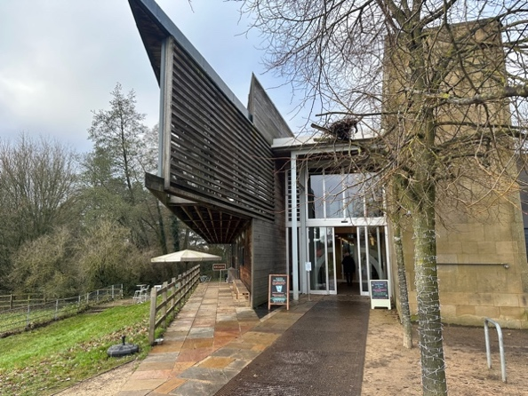
Main entrance: Visitor Centre
- The main entrance has level access: inside the doors is anti-slip matting; the main flooring on the ground floor is large stone slabs
- There are two sets of sliding automatic doors with contrasting markings on the glass at either end of the visitor centre building
- The width of these doors when fully open is 1.2m

Getting around inside
Layout of the building
The facilities within the Visitor Centre are positioned over two floors:
- Ground floor: Information Desk, toilets, shop, coffee shop, Quiet Room, and hireable spaces
- First floor: The Kitchen Café, Upper space exhibition gallery, toilets
The ground floor features a main concourse that runs the length of building, with 28m of floor to ceiling glass windows along one side.
There are wooden benches along the length of the concourse.
- Full length of concourse: 64m
- Width of concourse: 3.5m (at narrowest point)

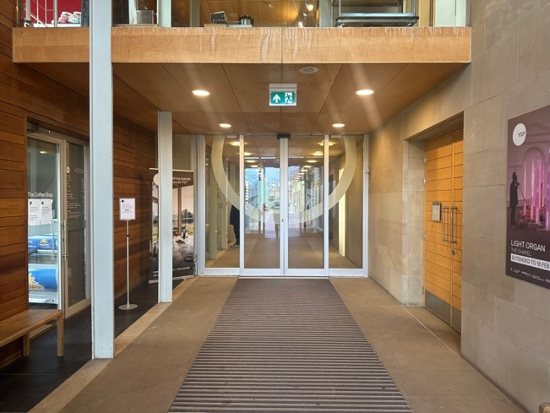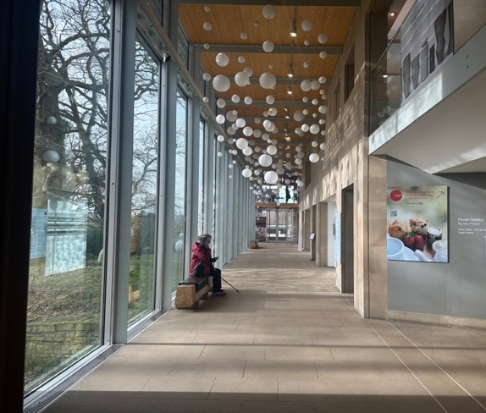
Lighting
The lighting is a mixture of natural light, low LED lights and downcast spotlights.

Sensory information
- The Visitor Centre can get busy with groups of people, especially during the middle of the day
- The building can be echoey at times
- There can be food and coffee smells from the cafes
- Dogs are allowed to walk through the visitor centre

Lift
- There is a lift at either end of the Visitor Centre
- Both lifts are the same type of lift and the same dimensions
- The lift opposite the Information Desk goes between the ground floor and first floor
- The lift at the far end of the building (away from the car park) goes between the ground floor and first floor Upper Space Gallery, and also down to a basement level to provide level access to the Underground Gallery
- Lift door opening width: 87cm
- Internal measurements:
  - Width: 1.1m
  - Height: 2.1m
  - Depth: 1.4m
- The lift buttons have raised numbers or letters
- The lift has a capacity of 630kg or eight persons
- There is good visual contrast in the lift with a light coloured stone floor and coloured walls.

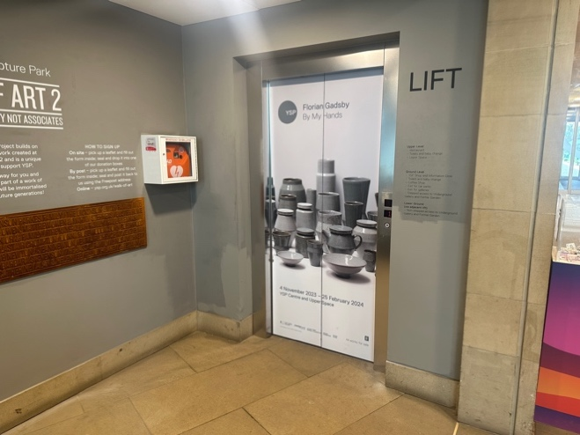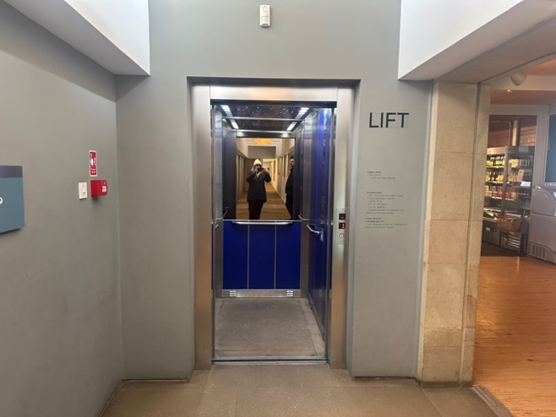

Accessible toilet – ground floor
- Located 15m from main entrance doors
- The toilet door is 85cm wide
- The direction of transfer onto the toilet is to the right
- The toilet seat is 59cm high
- There is 1.37m at the side of the toilet. There is 1.1m in front of the toilet.
- There are four handrails. Two on the left-hand side and two on the right-hand side when sitting down
- The sink is 89cm high
- The toilet has baby changing facilities

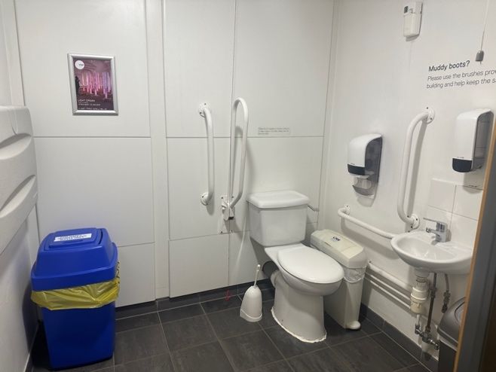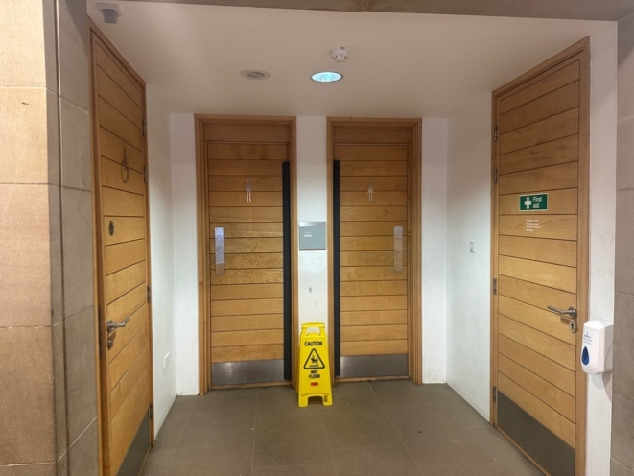

Accessible toilet first floor:
- There is level access to access the toilet from the lift or The Kitchen Café, located immediately next to the lift
- The toilet door is 88cm wide
- The direction of transfer onto the toilet is to the left
- The toilet seat is 59cm high
- There is 85cm at the side of the toilet. There is 1.3m in front of the toilet.
- There are four handrails. Two on the left-hand side and two on the right-hand side when sitting down
- The sink is 89cm high
- The toilet has baby changing facilities

Information Desk (ground floor)
- The Information Desk is located off the main concourse
- The desk is staffed during opening hours
- The height of the lower section of the desk is 1.1m. The higher section is 1.2m.

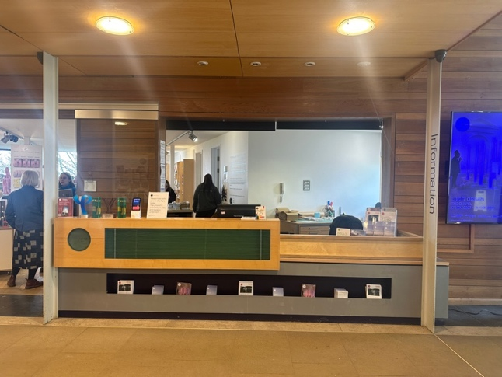

YSP Shop (ground floor)

- Level access from main concourse
- It is 19m from main entrance of the Visitor Centre to the shop
- Level wooden flooring throughout
- One entry/exit point. Doorway open during shop opening hours. Width is 1.47m
- It is 90cm from the door to the till point
- The height of the lower section of the shop counter is 630mm. The higher section is 1000mm.
- The shop layout features a number of free-standing display units at 750mm high, shelving units and display cases. The minimum distance between any of the furniture is 900mm.
- The shop is staffed by a friendly team during opening hours
- Low level background music is played in the shop
- There are scents of scented candles, diffusers, and soaps
- Mixture of lighting:
  - Natural light from windows
  - LED low level ceiling lights
  - Display lighting in cabinets

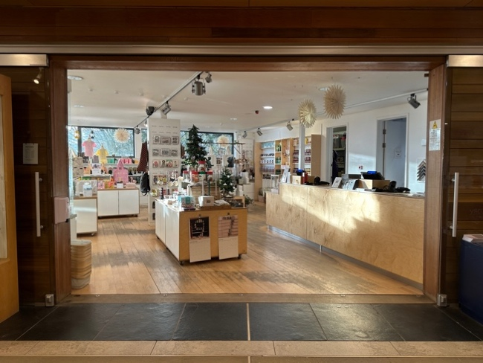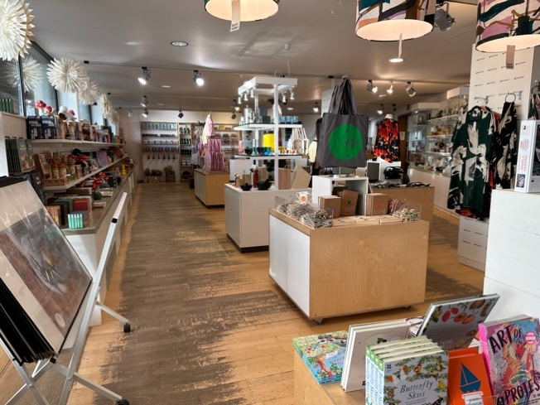

Quiet Room (ground floor)

Our Quiet Room, located just off the concourse in the Visitor Centre, is a quiet space for anyone who needs to take a bit of time out. There are books and sensory toys available, and a screen showing films of our current exhibitions. This screen does not have sound and can be turned off completely if required, just ask at the Information Desk.

- On the level access from main Visitor Centre concourse
- There is no door at the entrance to the room
- The entrance is 1.5cm wide
- The flooring is carpet
- Seating:
  - Three soft cushioned sofas. Seat height: 37cm
  - Two plastic chairs. Seat height: 48cm
  - Two wooden stools: Seat height: 47cm
- There is a drawer unit with information leaflets. Height: 70cm
- There is a desk visitors can sit at. Height: 79cm
- The lighting is ceiling spotlights.

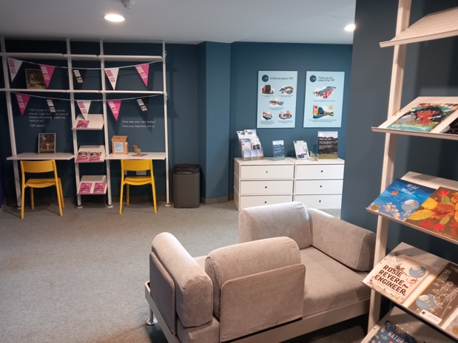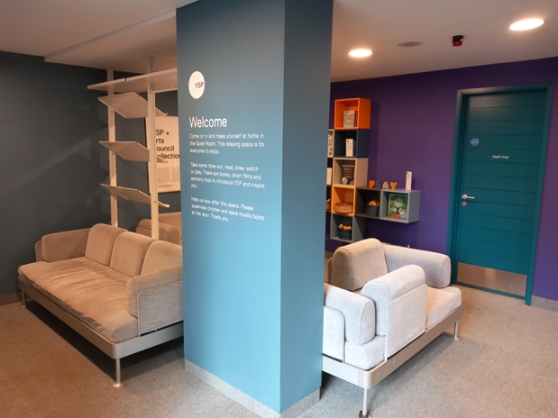

The Coffee Shop (ground floor)

- There are two entrances to the coffee shop:
  - On the level access from inside the Visitor Centre
  - On the level access from outside the Visitor Centre
- The width of the doorway from inside the Visitor Centre is 91cm
- The door is open when the coffee shop is open
- The width of the doorway from outside the Visitor Centre is 97cm
- The is a manual door that opens towards you (in good weather, this door is kept open)
- A team member will be present behind the serving counter during opening hours
- The height of the serving counter is 95cm
- The height of the counter with milk/sugar/serviettes is 90cm
- The height of the handles of the self-service drinks fridge is 1.1m
- There is no indoor seating
- Outdoor seating includes:
  - Benches on the level. Seat height: 45cm
  - Flexible seating with loose tables and chairs located on a lower level accessed by six steps
  - There are round, circular metal tables and metal chairs. There are smaller and larger tables, all with one central leg and four feet:
  - Height of clearance of larger tables: 70cm
  - Height of clearance of larger tables: 67cm
  - Height of chair seat: 43cm
  - All chairs have arms

The Kitchen Café (first floor)

- From the main entrance to the dining area, there is level access via a lift. The distance from the lift to the dining area is 6m.
- There is no door at the entrance to the café
- The café is self-service. If you need table service, staff can help you.
- We cater for gluten free (celiacs), vegetarian and vegan specific diets. Full allergy information is available.
- The café features:
  - A self-service area and hot food counter
  - Till counter
  - Cutlery and condiments unit
  - Indoor seating area
  - Outdoor seating area
- The width of the self-service counter area is 1.9m
- The height of the self-serve cold food and hot food counter is 88cm
- The height of the till counter is 88cm
- The height of the cutlery and condiments unit is 90cm
- The indoor seating area has level access with laminate flooring
- There is flexible seating with loose tables and chairs.
- Indoors, there are white rectangular or square tables configured in tables to seat two, four or six people.
- The tables are 72cm high. They have a clearance of 70cm to the underside.
- There are wooden seats with solid backs. The seat height is 45cm
- There is background music
- Manual, sliding glass doors with a width of 3m lead to the outdoor seating area
- On warmer days the sliding doors are kept open, on colder days visitors open and close them as they pass between them. The café team will happily open/close them for you.
- The outdoor seating area has a level floor surface of wooden decking
- There are circular metal tables with a clearance height of 70cm
- There are metal chairs with a seat height of 43cm

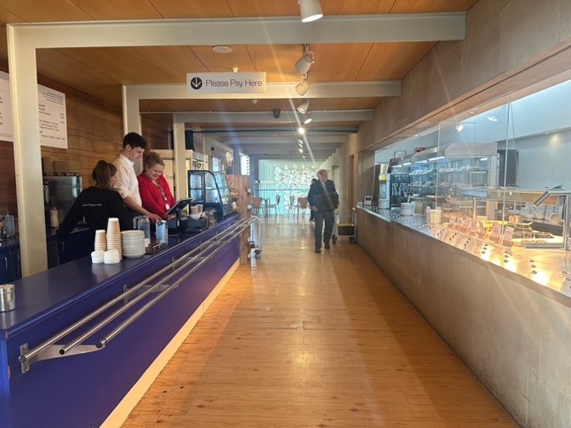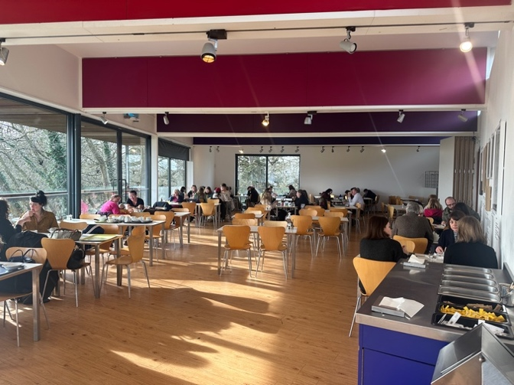

Upper space (art gallery / first floor)

From the lift nearest The Kitchen Café:
- On the level from the lift
- Distance from the lift by The Kitchen Café: 37m
- Width of corridor on this route: 90cm (at the narrowest point)
- Flooring of corridor: stone slabs
- There is a door at the end of the corridor. This is a manual door that opens away from you. Width of doorway is 91cm
- There is a door at the entrance to the Upper Space. This is a manual door that opens towards you. The door will close behind you. Width of door opening is 96cm

From the lift at the far end of the Visitor Centre:
- Distance from the lift at the far end of the building is 2m
- Width of corridor on this route is 2m
- Flooring of corridor: stone slabs
- There is a door at the entrance to the Upper Space. This is a manual door that opens towards you. The door will close behind you. Width of door opening is 90cm

Upper Space itself:
- Flooring of gallery: grey vinyl with circular relief pattern
- Lighting: mixture of natural lights and spotlights
- Height of rail overlooking the Visitor Centre concourse is 1.1m

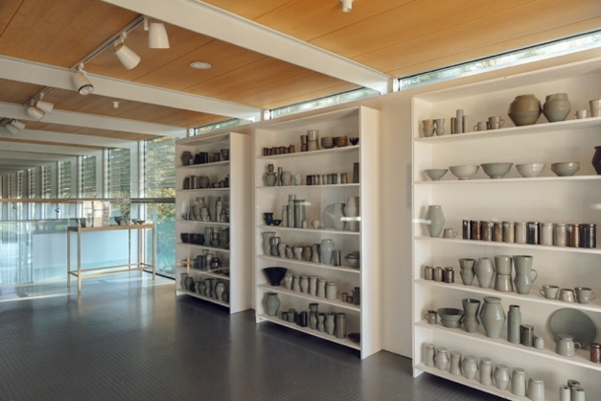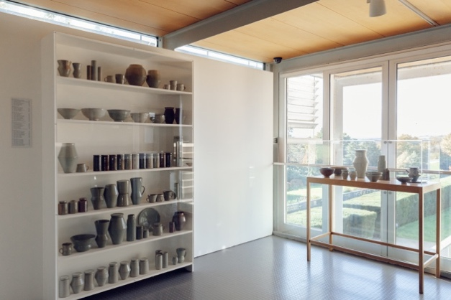

YSP Learning Building and Café

Café arrival and layout
- Entrance is on the level
- Automatic sliding door. Width of door opening 1m
- The café is self-service. If you need table service, staff can help you.
- Distance from the door to the counter is 10m
- Height of serving counter 90cm
- The height of the counter with milk/sugar/serviettes is 73cm
- There is indoor and outdoor seating, both on the level
- There is grey vinyl flooring throughout and a large dark mat at the entrance
- Indoors: There are grey square tables configured in tables to seat two, four or six people, and white round tables that seat two-four people. All tables have a central leg with four feet.
- The grey square tables have a clearance of 68cm to the underside.
- The white round tables have a clearance of 67cm to the underside.
- There are wooden seats with solid backs. The seat height is 44cm.
- There are circular metal tables with a clearance height of 70cm
- There are metal chairs with a seat height of 43cm
- The café at Learning is dog friendly, with seating available for visitors with dogs. There is an area where dogs are not permitted for those who would prefer to be seated away from dogs.

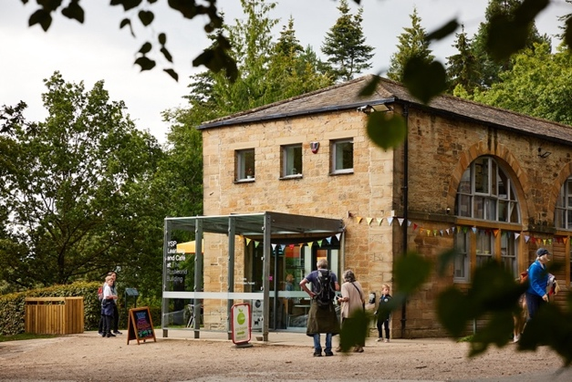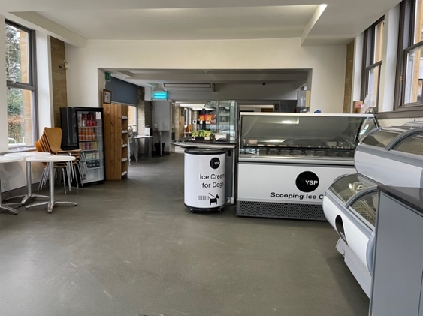

Accessible toilet:
- Toilets are in a different part of the Learning Building
- To the left of the café door, there is level access to another entrance to the building
- The door is automatic and opens out towards you
- The width of the entrance door is 1m
- The distance from the entrance to the accessible toilet is 10m
- The flooring is vinyl with a mat at the entrance
- There is a slight downhill slope towards the accessible toilet
- The width of the corridor is 1m (narrowest point)
- The toilet door is 91cm wide
- The direction of transfer onto the toilet is to the left
- The toilet seat is 48cm high
- There is 80cm at the side of the toilet. There is 1m in front of the toilet.
- There are four handrails. One on the left-hand side and one on the right-hand side when sitting down. There is a handrail above the sink on either side.
- There is a moveable handrail fixed to wall of the right-hand side of the toilet (when seated)
- The sink is 70cm high
- The toilet has baby changing facilities

Changing Places Toilet:
- The distance from the entrance of the building is 1m
- Access to the toilet is via a Radar Key. A key can be provided by the team in the café.
- The toilet door is 86cm wide
- There are moveable handles that can be moved up and down, located on either side of the toilet
- The toilet seat is 46cm high
- The height of the sink is adjustable. There is a control unit to the right of the sink. The lowest height of the sink is 55cm. (The control can also be used to release hot or cold water, use or remove the plug and put the light above the mirror on).
- There is 2.2m at the side of the toilet. There is 1.5m in front of the toilet.
- There are four handrails. Two either side of the toilet, one to the right of the sink and one to the left of the paper towel dispenser
- The paper towel dispenser is 93cm from the floor
- The bed is adjustable

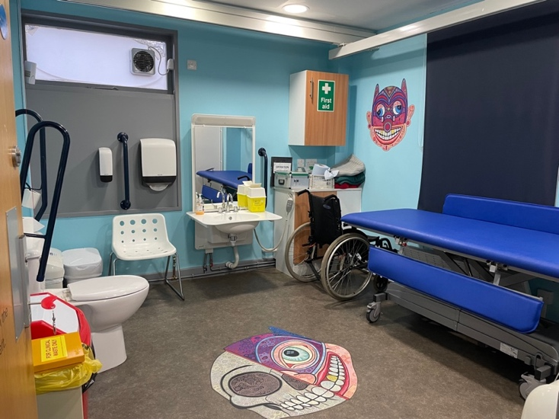

Getting around the Learning Building

Layout of the building
The building consists of two floors:
- Ground floor: Toilets and Garden Studio workshop room
- First floor: Hayloft workshop room

Lift
- There is one lift inside the building that goes between the ground and first floor.
- The lift is a platform lift
- The lift door is 92cm wide and opens towards you
- Internal measurements:
  - Width: 1.67m
  - Depth: 1.64m
- Outside, the lift button is raised and is illuminated with a green light
- Inside, the lift buttons have raised numbers and braille
- To operate the lift, the relevant floor button needs to be held down for the duration of the journey between floors.
- The lift has a capacity of 410kg or five persons.

Garden Studio
- Accessed on the level from the ground floor
- Distance from main entrance is 10m
- Distance to accessible toilet is 9m
- Distance to Changing Places toilet is 9.5m
- Corridor leading to the room is 1.3m (at narrowest point)
- The is a door at the entrance to the room
- The door is opened manually and opens towards you
- Width of doorway is 91cm
- There is vinyl flooring throughout
- One length of the room is floor to ceiling windows
- Lighting is a combination of natural light and fluorescent strips
- Tables and chairs are configured depending on the needs of a workshop
- The tables are 75cm high. They have a clearance of 71cm to the underside.
- There are white plastic chairs with a seat height of 43cm

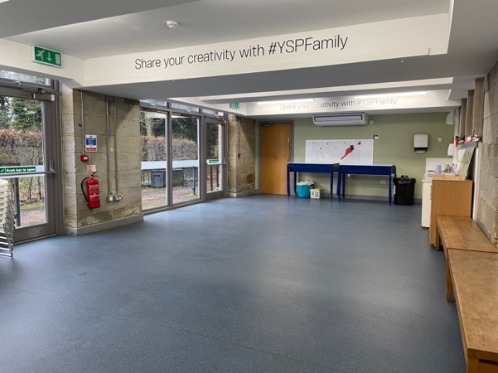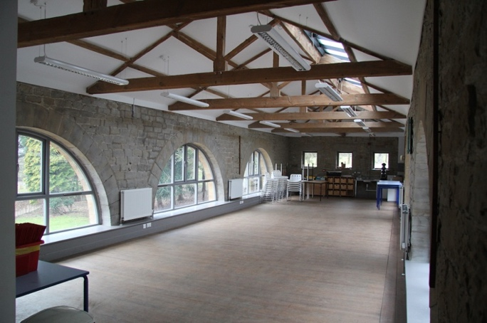
Garden Studio Hayloft

Hayloft
- Accessed on the level from the lift
- Distance from the lift is 4m
- Distance to accessible toilet (via lift) is 6m
- Distance to Changing Places toilet (via lift) is 10m
- Corridor leading to the room is 91cm
- The is a double door at the entrance to the room
- Both doors open manually and open towards you
- Width of doorway: 91cm (total width when both doors are open is 1.35m)
- There is wooden flooring throughout
- Lighting is a combination of natural light and fluorescent strips
- Tables and chairs are configured depending on the needs of a workshop
- The tables are 75cm high. They have a clearance of 71cm to the underside.
- There are white plastic chairs with a seat height of 43cm

The Weston

Arrival and building layout

The Weston is a building that features a restaurant, shop, and art gallery. The building can be accessed from inside the Park or from the entrance off Huddersfield Road. The Weston has its own entrance and car parking.
Blue Badge parking is available at The Weston, with 8 spaces available approximately 34m from the main entrance to the building. These spaces are on self-binding gravel, leading onto the path at Walk of Art 2, an embossed metal walkway. The general parking spaces nearest to the main doors are on loose hardcore and may not be suitable for all Blue Badge holders.

The building is all on one level.

- The entrance from the car park has a power assisted door
- The width of the door when open is 154cm
- There is smooth concrete flooring throughout the building
- The entrance from the Park has a manual door that opens into the building
- The width of this door is 1.5m
- The width of the entrance area (wall to wall) is 3.7m
- The sofa and armchairs in the entrance area are 40cm high and 50cm deep.

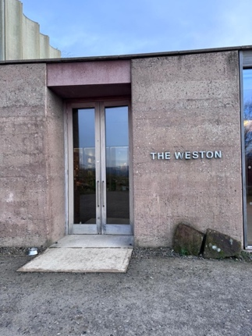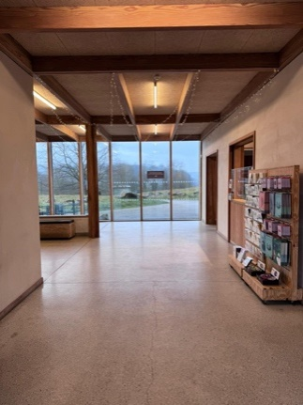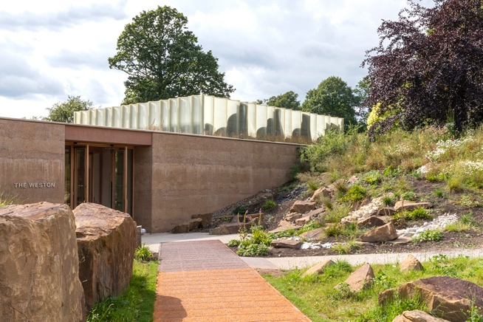

The Weston Restaurant

- The restaurant is located 17m from the entrance off the car park, and 13m, from the entrance when arriving from the Park.
- The corridor to the restaurant is 2.7m wide.
- There is a short downhill gradient into the restaurant
- There is indoor and outdoor seating
- In the indoor and outdoor areas, there is flexible seating with loose tables and chairs.
- Indoors, there are wooden rectangular or square tables configured in tables to seat two, four or six people.
- The tables are 77cm high. They have a clearance of 31cm to the underside
- There are wooden seats with solid backs. Some seats have upholstered padding. The seat height is 46cm
- There is background music
- The restaurant features floor to ceiling windows down two sides of interior
- Lighting is a combination of natural light and ambient spotlights
- The door to the outside seating area is 1m wide. The outdoor seating area can also be accessed by the rear entrance doors to The Weston building, which are 1.5m wide.
- Outdoors, there are rectangular or square metal tables configured in tables to seat two, four or six people.
- The tables are 77cm high. They have a clearance of 71cm to the underside.
- The seat height is 46cm.

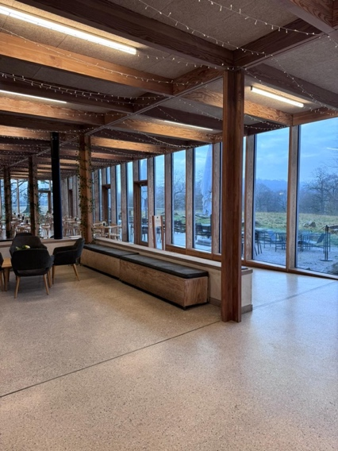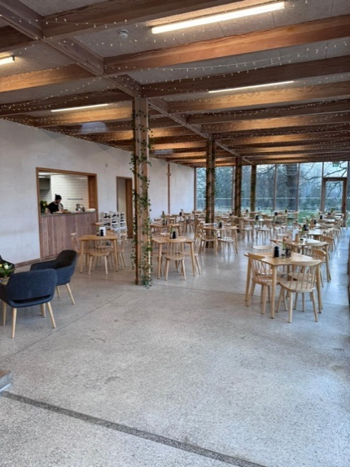

Shop

- Level access from main concourse
- The shop is located 5m from the main entrance, and 11m, from the entrance when arriving from the Park.
- There is no door separating the shop from the foyer
- The width to the entrance to the shop is 1.7m
- The distance from the entrance of the shop to the till is 3m
- The height of the lower section of the shop counter is 78cm. The higher section is 1m.
- The shop layout features several free-standing display units at 75cm high, shelving units and display cases. The minimum distance between any of the furniture is 90cm.
- The shop is staffed by a friendly team during opening hours
- Low level background music is played in the shop
- There are scents of scented candles, diffusers, and soaps
- Mixture of lighting:
  - Natural light from windows
  - LED ceiling lights

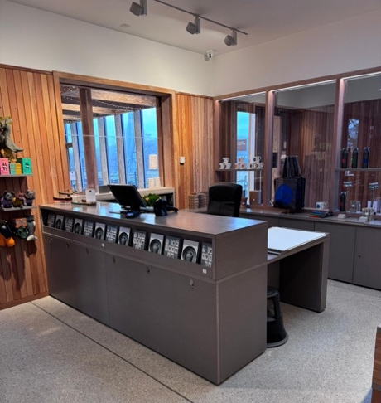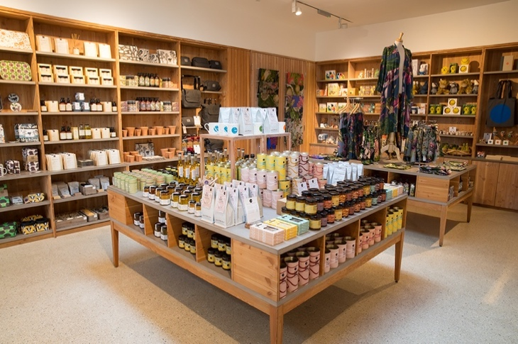

Weston Gallery

- The gallery is located 16m from the entrance off the car park, and 1m from the entrance when arriving from the Park.
- The is a door at the entrance to the room
- The door is opened manually and opens in the room
- The width of the doorway is 1.65m
- For some exhibitions, the door is propped opening during opening times
- The gallery is staffed by a friendly team member during opening hours

The layout and lighting of the room changes for each exhibition. For exhibition specific access information, please visit our exhibition pages.

Accessible toilet

- There is level access to the toilet from within the building
- The toilets are located 4m from the entrance off the car park, and 11m from the entrance when arriving from the Park.
- The toilets are located 14m from the restaurant entrance.
- There is a door at the entrance to the toilets
- This is a manual door that opens into the room
- The entrance door is 90cm wide
- The room features individual toilet cubicles with shared handwashing facilities. Each cubicle is individually labelled
- The accessible toilet is located 3m from the entrance to the toilets. It is directly opposite the entrance
- The door to the accessible cubicle is 92cm wide
- The direction of transfer onto the toilet is to the left
- The toilet seat is 59cm high
- There is 1.5m at the side of the toilet. There is 1.5m in front of the toilet.
- There are four handrails. Two on the left-hand side and two on the right-hand side when sitting down
- The sink is 74cm high

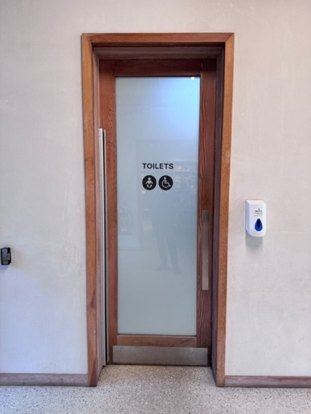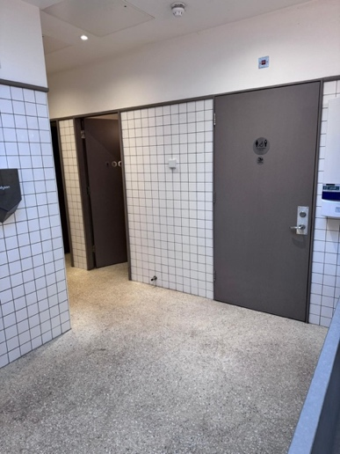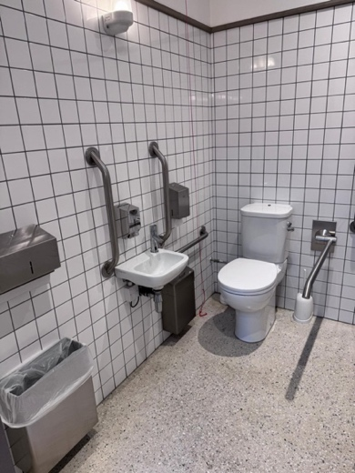
Underground Gallery

Arrival
- From the Visitor Centre, the gallery is accessed by a flight of outdoor stairs (32 steps) or internal passenger lift.
- The distance from the lift to entrance to the gallery is 57m
- The route from exiting the lift to the entrance to the gallery is outside
- On exiting the lift at level -1, there is a set of sliding automatic doors which lead outside. The width of these doors is 1.5m
- The route to the gallery is on the level. There is a shallow ramp on the approach to the gallery door. The ground surface is a mixture of compacted, fine gravel and smooth stone slabs.
- There is a sliding automatic door to the entrance to the gallery with an open width of 2.2m
- Just inside the entrance is a large, brush door mat. This is the vestibule area.
- There is a second sliding automatic door leading into the exhibition area of the gallery. The width of the door is 2.2m
- Entry and exit of the gallery are through the same door

Layout and getting around

The layout and lighting of the individual rooms changes for each exhibition. For exhibition specific access information, please visit our exhibition pages.

- The interior of the building is on the level
- The layout of the building features:
  - An entrance area with desk
  - A long corridor, approximately 62m long, from which you can access individual exhibition galleries.
  - A room at the end of the corridor with interactive activities
- The flooring is smooth concrete surfaces in the entrance area and within the exhibition galleries
- There are stone flags on the corridor that runs the length of building
- There are no doors separating the galleries from the corridor. The open doorways are 3880mm wide
- The width of the corridor is 28.6m
- The width of the corridor leading to the interactive gallery is 1.6m
- There are two wooden benches located in the corridor. Seat height is 41cm
- The exterior wall running down the length of the corridor has floor to ceiling glass windows.
- There are always team members located in the gallery
- There are no public toilet facilities in the Underground Gallery

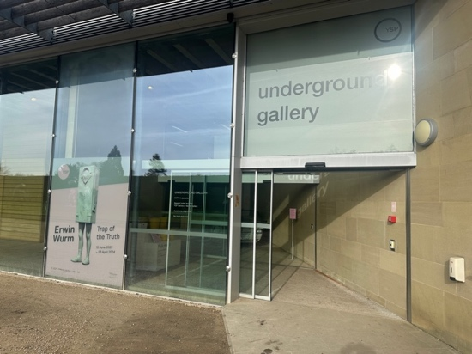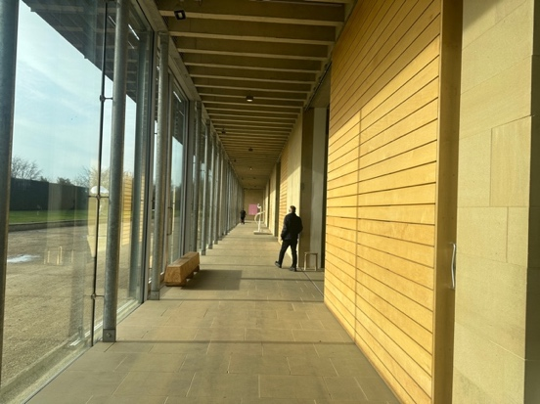

Chapel

The Chapel is a converted 18th-century chapel which now houses our temporary exhibition programme. It is a Grade II listed building.

Arrival
- The chapel is located 500m from the visitor Centre and is accessed via the Country Park. This is an outdoor route across steep grassy inclines.
- Route:
  - Head out of the visitor Centre towards the car park, and along the flat path until level with the grass on your right-hand side
  - Turn back on yourself and follow the level grass and gravel path along the fence line until you reach the gate
  - The gate opens manually via a lever. It opens both ways.
  - Follow the downhill path across the grass. Cross the tarmacked road and turn left at the next junction of pathways
  - Follow the level gravel path to the entrance of the chapel.

- There are metal gates at the entrance to the chapel grounds. The gates have a manual latch to open the gates. The latch is 1.25m high from the ground. The gates open into the grounds.
- There is ramped access to the entrance door. Once through the gates, the ramp starts immediately on the left. The ramp is a grassy incline that meets the level of the door.
- Entry and exit of the gallery are through the same door
- The chapel door is a manual door which opens into the building. During the summer months, the door might be kept open during opening hours.
- The width of the door is 1m

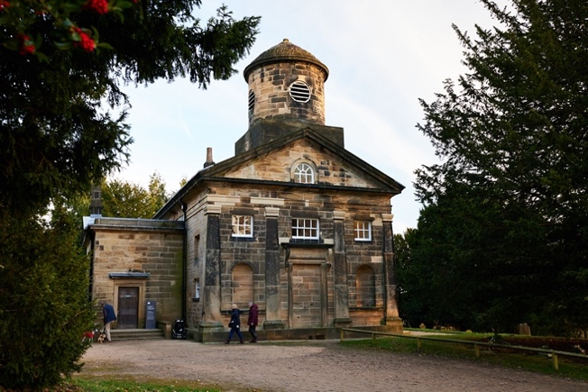

Layout and getting around

The layout and lighting of the individual rooms changes for each exhibition. For exhibition specific access information, please visit our exhibition pages.

The building consists of:
- An entrance corridor – ground floor
- An introductory area to the exhibition – ground floor
- Exhibition gallery (former nave of the chapel) – ground floor
- Balcony (first floor)

- The ground floor is on the level. There are stone flags on the ground floor with a mat in the entrance area. A metal grate runs along the floor in the centre of the of the exhibition area.
- The open doorway into the introductory area is 1m.
- The introductory area is 2.3m wide
- The distance from the chapel door to the exhibition area is 4.6m
- There are wooden benches in the introductory area with a seat height of 44cm
- The upper balcony is accessed by a steep, sharply turning staircase. There are 18 steps.
- There is traditional pew seating on the balcony
- There are always team members located in the Chapel
- There are no public toilet facilities in the Chapel

Outdoor Areas
There is a network of pathways around YSP’s vast grounds. Across the 500 acres, there are formal gardens, open Country Park, lakeside paths and woodland areas. Each have their own different terrain and path width.
The Park is situated in a valley with paths going downhill towards the lakes. The elevation changes by 75metres, from the highest point in the Park to the lowest.
Some outdoor areas of the Park can be difficult to access due to uneven terrain and weather-related changes. Our friendly team at the YSP Centre Information Desk can advise on suggested routes for wheelchair and mobility scooter users. Come and say ‘hello’ on your arrival.
The immediate outdoor areas to the visitor centre are the Formal and Bothy Gardens and Country Park. The Formal and Bothy Gardens can be accessed via taking the lift in the Visitor Centre to level -1 and exiting through the sliding, automatic doors. The area features level, bonded gravel paths and some steady inclines.
The Country Park can be accessed out of the front of the Visitor Centre, along the flat pathway and then turning back on yourself when level with the grassy bank. Follow the path back along the fence towards the gate. The area features steep grassy paths which can get muddy during winter months.
There are 90 benches located in the outdoor grounds. The majority of the benches are located in the Formal and Bothy Gardens, Country Park and in Lower Park. There are different types of benches including wooden benches with or without backs.

Types of ground surfaces:

Bonded gravel
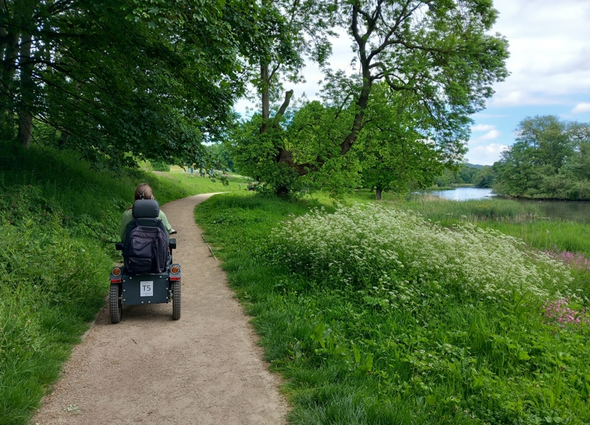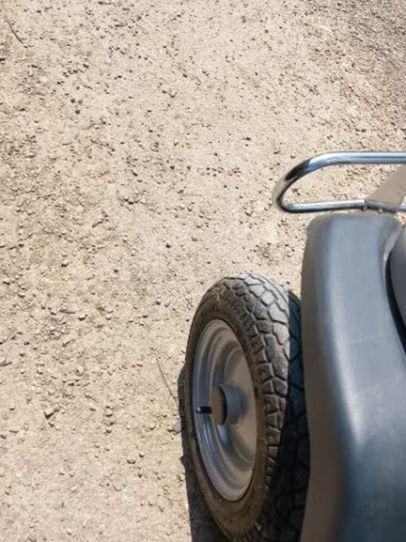

Loose gravel
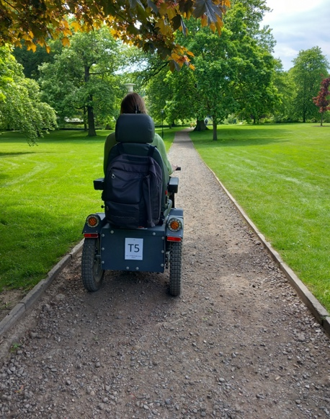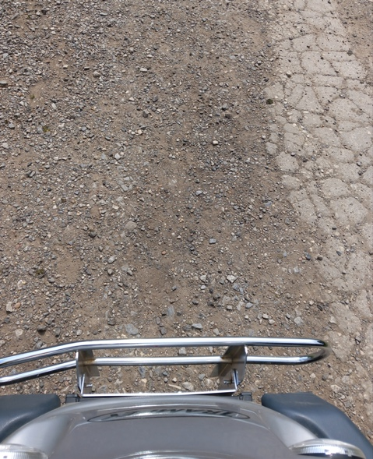

Grass paths
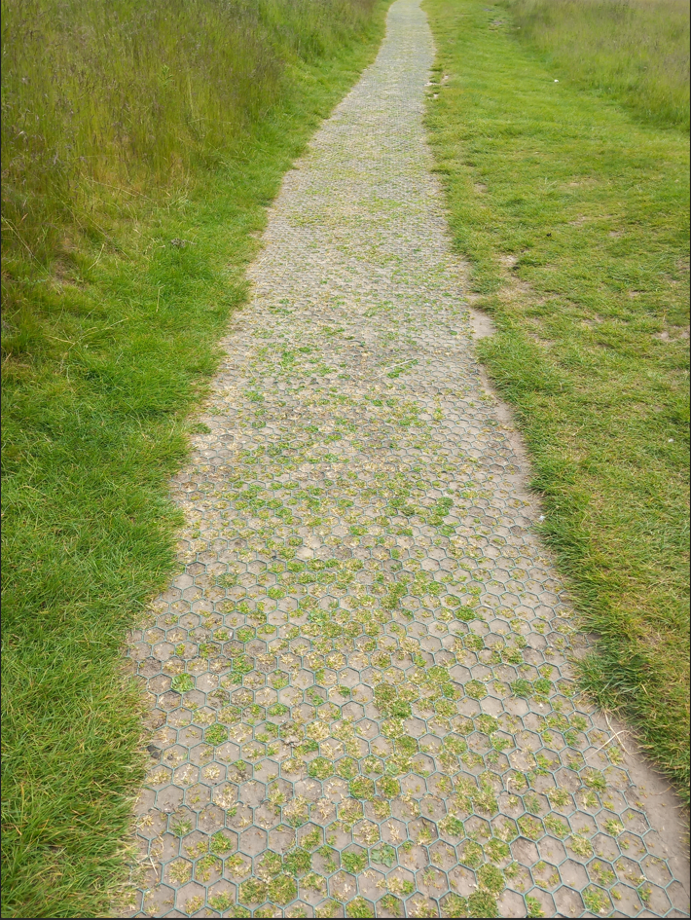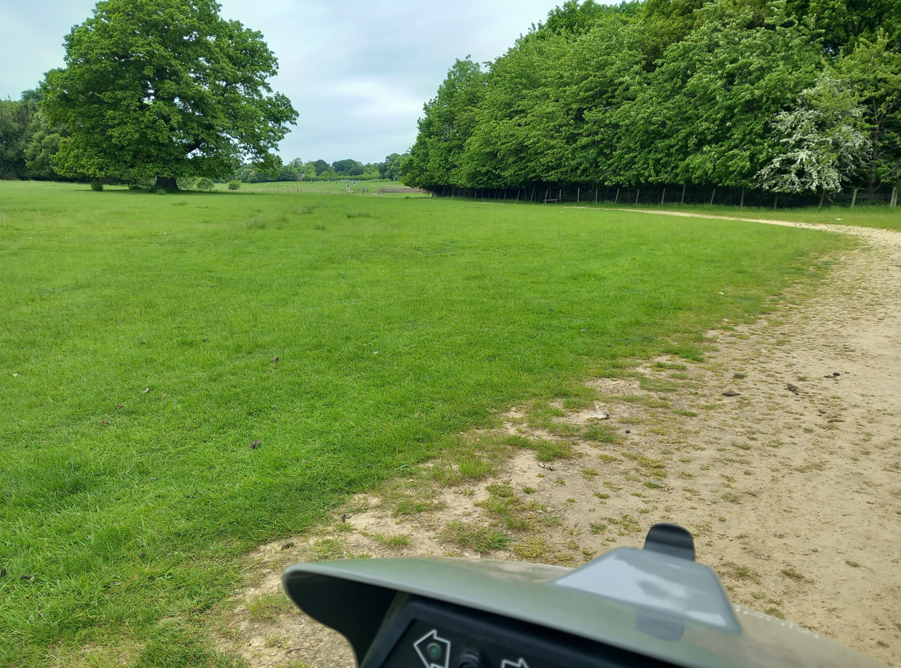

Paved paths
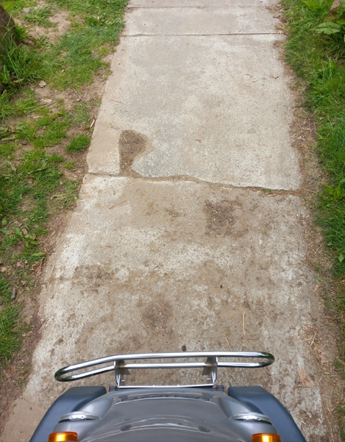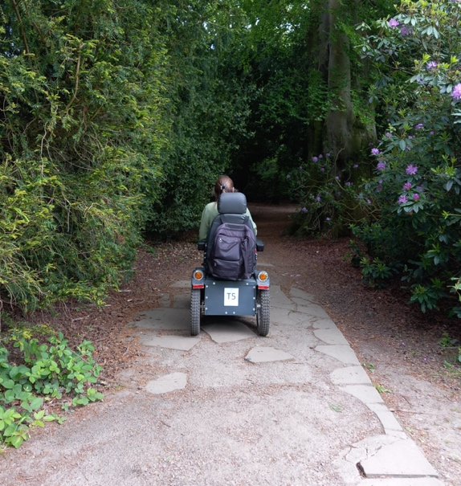

Tarmacked paths
